Clement Newton Smith
June 16, 1878 – January 18, 1942

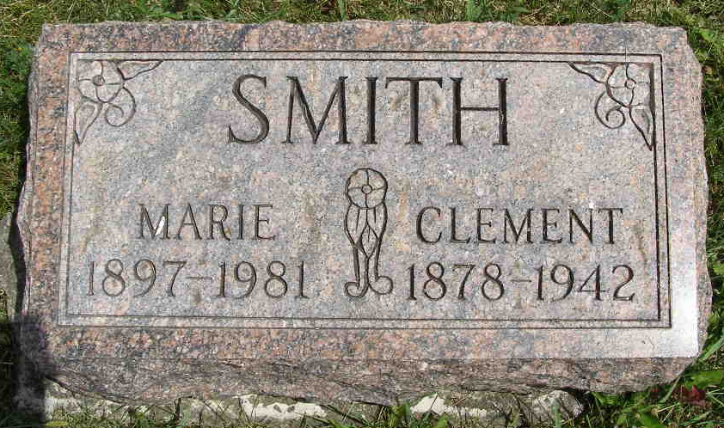
Photo by Shaunda Bedwell Opdycke
Indiana, U.S., Death Certificates, 1899-2017

Name Clemont Newton Smith
Gender Male
Race White
Marital Status Married
Age 63y 7m 2d
Birth Date 16 Jun 1878
Birth Place Berne Adams Co Indiana
Death Date 18 Jan 1942
Death Place Fort Wayne, Allen, Indiana, USA
Death Registration Date 1942
Father Samuel Smith
Mother Loucinda McClair
Spouse Marie Smith, informant
Burial 1-21-1942 M.R.E.

