Cecil Esther (Keller) Smith
August 9, 1912 – January 26, 2005

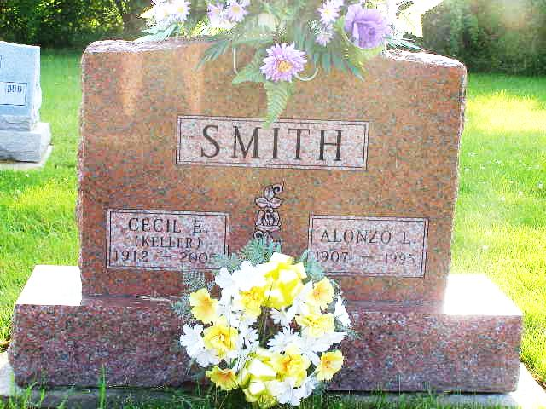
Photo by Shaunda Bedwell Opdycke

CECIL E. SMITH, 92, of Berne, died Wednesday, Jan. 26, 2005, 1:24 p.m., at Adams County Memorial Hospital.
Surviving are daughter, Mrs. Howard (Eloise) Nussbaum of Monroe; sons, Chester (Phyllis) Smith of Monroe and Lester (Pam) Smith of Decatur; sisters, Gladys Haiflich of Bluffton and Juanita Masterson of Markle; eight grandchildren; 19 great-grandchildren; and four step-great-grandchildren.
She was preceded in death by her husband, Alonzo Smith, in Nov. of 1995; brother, Cleophus Keller; sisters, Irene Death, Ruby Keller and Leona Miller; and grandson, Steven Nussbaum.
Funeral service is 2:30 p.m. Sunday at Yager-Kirchhofer Funeral Home, Berne, with visitation one hour prior to service. Visitation also from 2 to 5 and 6 to 8 p.m. Saturday at the funeral home.

Journal Gazette, The (Allen County, Indiana)
Thursday, January 27, 2005

