Catherine M. (Habegger) Smith
January 30, 1938 – May 1, 2019

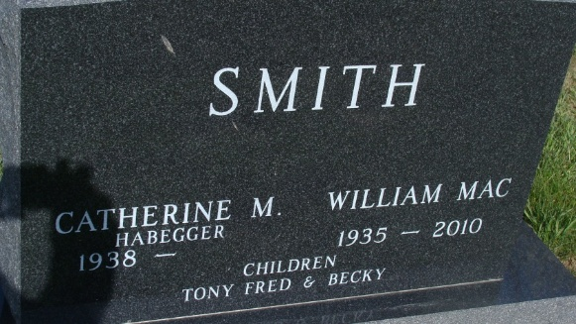
Photo by Alicia Kneuss
Catherine M. “Kate” Smith, 81, of Geneva, Indiana passed away on Wednesday May 1, 2019 at Swiss Village in Berne. She was born on January 30, 1938 in Wells County, the daughter of the late Edgar Habegger and the late Savilla (Roth) Habegger. Kate was united in marriage to William “Mac” Smith at the First Mennonite Church in Berne, on October 14, 1956. They were married for 53 years before Mac went to heaven in March 2010.
Kate was a lifelong member of the First Mennonite Church. She served the church in many different capacities. Kate was a homemaker and worked at EP Graphics in Berne, before retiring in 2000.
Her life had been a great adventure in faith and frequent travels to meet with and enjoy her family, relatives and friends. Her children and her family were the ultimate joy and love of her life. She spent as many wonderful hours as she could with her family and extended family, always around laughter and lots of good food.
Survivors include two sons, Tony (Mary Ann Weis) Smith of Indianapolis and Fred (Lori) Smith of Fishers; daughter, Rebecca (Kent) Werst of Geneva; two sisters, Hannah (Richard) Amstutz of Berne and Sara (Robert) Amstutz of California; seven grandchildren, Michael (Maxi) Smith, Jessica (Matt) Marks, Jackson (Destiny) Werst, Isaac Werst, Jacob Werst, Parker Smith, and Logan Smith; two great-grandchildren, Hayden Marks and Rhett Smith.
Kate was preceded in death by five brothers, Howard Habegger, Benjamin Habegger, Chester Habegger, Paul Habegger and Alvin Habegger; and sister Eldonna Amstutz.
Funeral services will be held at 2:00 p.m. Sunday, May 5, 2019 at First Mennonite Church in Berne with Pastor Jim Schwartz officiating. Interment will follow in the M.R.E. Cemetery in Berne, Indiana. Friends will be received from 2-7 p.m. Saturday, May 4, 2019 at the Zwick & Jahn Funeral Home, Yager-Kirchhofer Chapel Berne with visitation one hour prior to services at the church.
Preferred memorials can be made to First Mennonite Church Mission Fund or Family LifeCare Hospice.

Zwick & Jahn Funeral Home, Adams County, Indiana
May 2, 2019

