Catherine (Anderson) Smith
September 12, 1905 – October 8, 1990

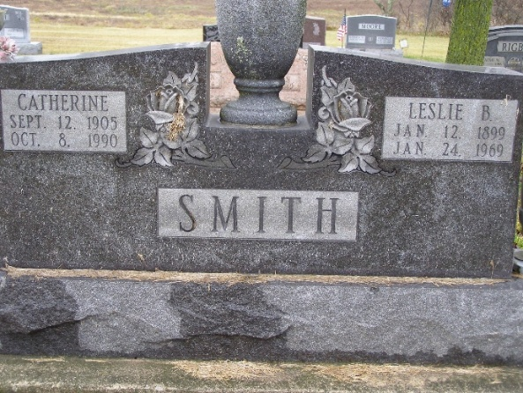
Photo by Shaunda Bedwell Opdycke

Indiana, U.S., Death Certificates, 1899-2017

Name Catherine Smith
[Catherine Anderson]
Gender Female
Race White
Marital Status Widowed
Age 85
Birth Date 12 Sep 1905
Birth Place Adams County, Indiana
Death Date 8 Oct 1990
Death Place Berne, Adams, Indiana, USA
Death Registration Date 1990
Father John Anderson
Mother Clara Hale
Informant Marilyn C. Muselman, daughter
Burial 10/10/1889 M.R.E.

