Betty J. (Christener) Smith
December 1, 1930 – March 22, 2003

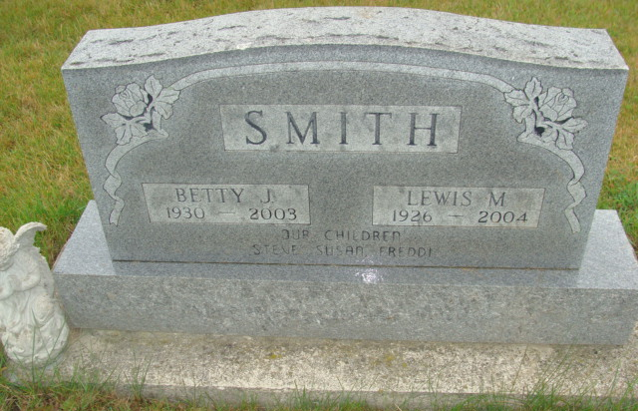
Photo by Alicia Kneuss

Betty J. Smith, 72, of Berne, died Saturday, Feb. 22, 2003, at Adams County Memorial Hospital. The Vera Cruz native was a previous member of Zion United Church of Christ in Decatur.
Surviving are her husband, Lewis M. of Berne; sons Steven of Decatur and Fred of Geneva; a daughter, Susan K. Rich of Atlanta; eight grandchildren; and four great-grandchildren. She is preceded in death by two infant brothers; and her sister, Beulah Affolder.
Services are 10:30 a.m. Wednesday at Yager Kirchhofer Funeral Home in Berne. Calling is from 2 to 8 p.m. Tuesday at the funeral home. Burial will be at MRE Cemetery.
Memorials are to Adams County Community Foundation Cancer Fund. Information provided by Yager Kirchhofer Funeral Home, Berne.
News-Sentinel, The (Allen County, Indiana)
Monday, February 24, 2003

