Alva Clayton Smith
June 15, 1888 – August 26, 1972

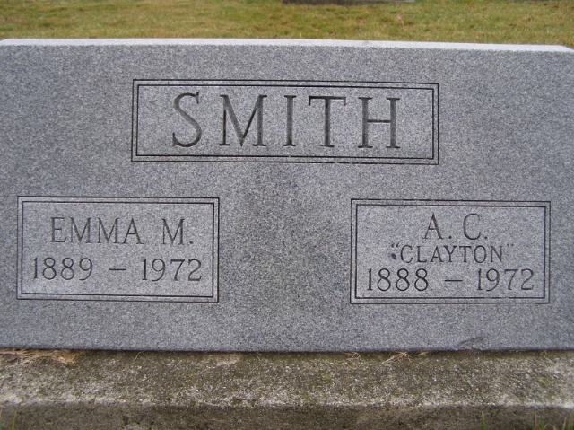
Photo by Shaunda Bedwell Opdycke

Alva C. Smith dies at Berne

Alva Clayton Smith, 84, of 255 Van Buren street, Berne, a retired salesman, died at 8:20 p.m. Saturday at the Berne nursing home, where he had been a patient since May 6. He was crippled in an auto accident in 1932.
A lifelong resident of Berne, he was born in that city June 15, 1888, to Martin L. and Drusilla Isabel Kern-Smith, and was married to Emma Bixler April 2, 1911. The couple celebrated their 61st wedding anniversary April 2 of this year. Mrs. Smith preceded her husband in death June 23 of this year.
Mr. Smith was a member of the Trinity United Methodist church at Berne.
Surviving are one son, Maurice M. Smith of Berne; three daughters, Mrs. Roy E. (Genevieve) Strickler of Decatur, Mrs. Arthur (Loyce) Anker of Fort Wayne, and Mrs. Corinne Miller of Berne; two sisters, Mrs. N. A. (Nora) Bixler of Decatur, and Mrs. Elmer (Gertrude) Stucky of Syracuse; a half-brother, Rev. Marion Smith of Frederick, Pa.; seven grandchildren and 12 great-grandchildren. Three brothers, Lester, Orva and Philip, are deceased.
Funeral rites will be held at 10:30 a.m. Tuesday at the Yager funeral home in Berne, with Rev. Homer W. Achor officiating. Burial will be in MRE cemetery. Friends may call at the funeral home after 3 p.m. today.

Berne (IN) Public Library Heritage Room
“More Misc Obits"
**

Rites Here on Tuesday for A. C. Smith, 84
Retired School Teacher and Salesman Dies Here Saturday

Alva Clayton Smith, 84, 255 Van Buren Street, died at 8:20 pm Saturday at the Berne Nursing Home where he was a resident. He had been in failing health for several years. His death followed that of his wife by two months. She died June 23 of this year.
Mr. Smith was a lifelong resident of this community and was widely known. He operated the Berne Dry Goods Store here for many years, being one of Berne’s early merchants. He was a traveling salesman, selling footwear, for many years. In addition, he measured and sold men’s suits in his home for a long time. He also taught school in his earlier years after attending Tri State College and Fort Wayne Business College.
Mr. Smith was badly hurt in a traffic accident in November of 1932, and he had not been well since. He went to the Berne Nursing Home May 6.
Mr. and Mrs. Smith observed their 61st wedding anniversary on April 2. Mr. Smith was born in Berne June 15, 1888, a son of Martin L. and Drusilla Isabel Kern Smith. He was married to Emma Bixler April 2, 1911 in Berne. He was a member of the Trinity United Methodist Church.
Surviving are a son, Maurice M. Smith, Berne; three daughters, Mrs. Roy E. (Genevieve) Smith, Decatur; Mrs. Arthur (Joyce) Anker, Fort Wayne and Mrs. Corrinne Miller, Berne. There are seven grandchildren and 12 greatgrandchildren. Two sisters, Mrs. Noah (Nora) Bixler, Decatur and Mrs. Elmer (Gertrude) Stucky, Syracuse, Indiana and a half-brother, Rev. Marion L. Smith of Fredericksburg, Pa., survive. Three brothers, Orva, Philip and Lester Smith preceded in death.
Services will be held at 10:30 am Tuesday at the Yager Funeral Home; Rev. W. Homer Achor will officiate and burial will be in the MRE Cemetery.

Death: August 26, 1972; Burial: August 29, 1972; Buried: MRE

Berne (IN) Library Heritage Room
MRE Obit Book 1966-1972

