Albert Daniel Smith
January 14, 1896 – October 5, 1918

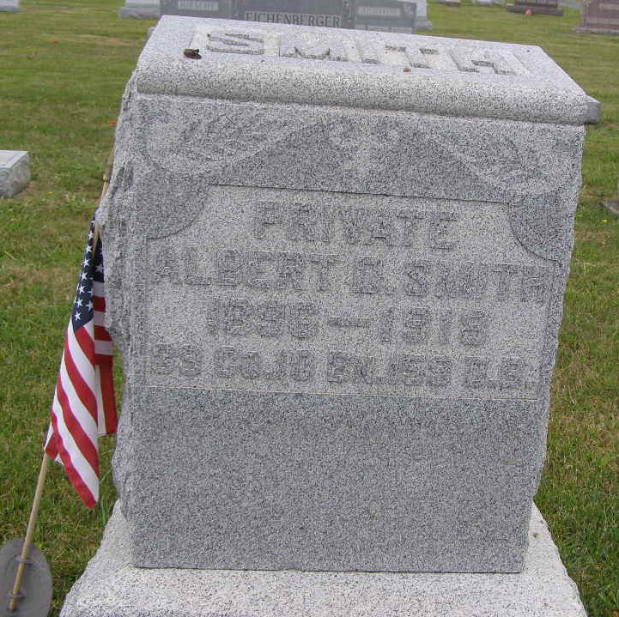
Photo by Shaunda Bedwell Opdycke

