Pamela Ann Smelser
June 7, 1951 – June 7, 1951

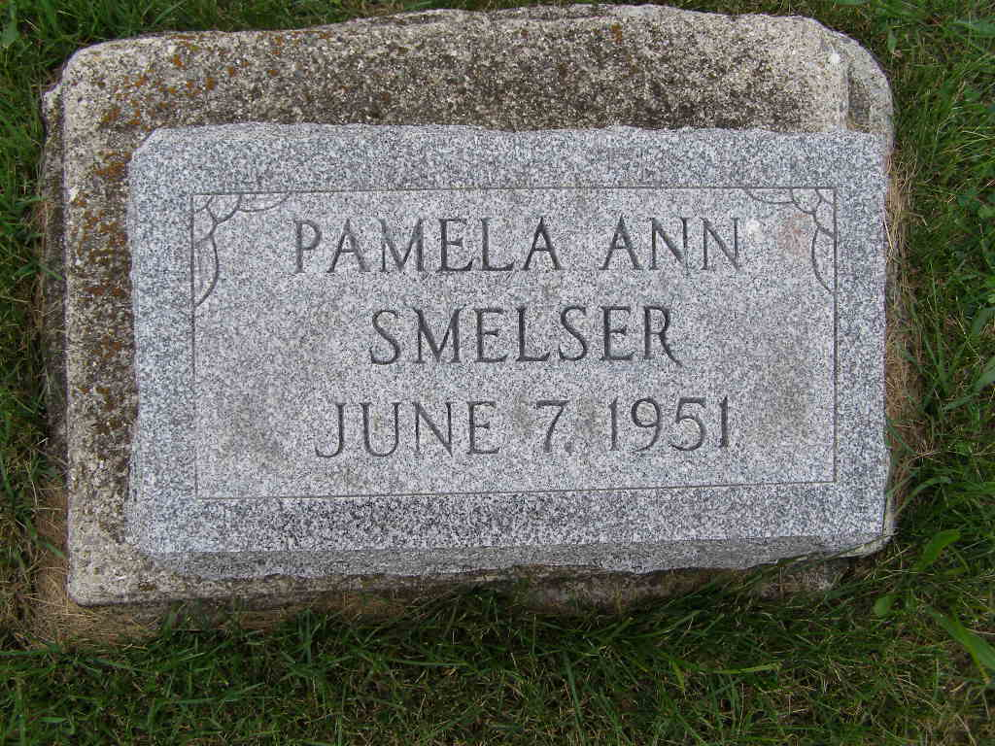
Photo by Shaunda Bedwell Opdycke

No further information found at this time.

