William Andrew Sipe
June 22, 1875 – May 21, 1924

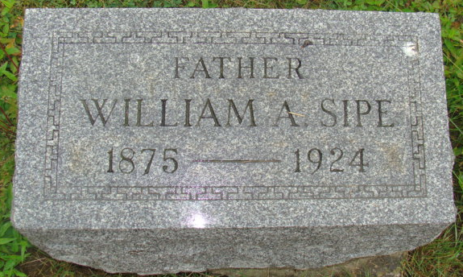
Photo by Alicia Kneuss

Indiana, U.S., Death Certificates, 1899-2017

Name Wiliam Andrew Sipe
Gender Male
Race White
Marital Status Married
Age 48y 10m 29d
Birth Date 22 Jun 1875
Birth Place Adams Co.Indiana
Death Date 21 May 1924
Death Place Buna, Adams, Indiana, USA
Death Registration Date 1924
Father Andrew J Sipe
Mother Cathren Fallen
Spouse Bertha Sipe
Informant Harvey L Sipe
Burial M.R.E. 5/23/1924

