Douglas J. Sipe
October 30, 1941 - February 17, 2009

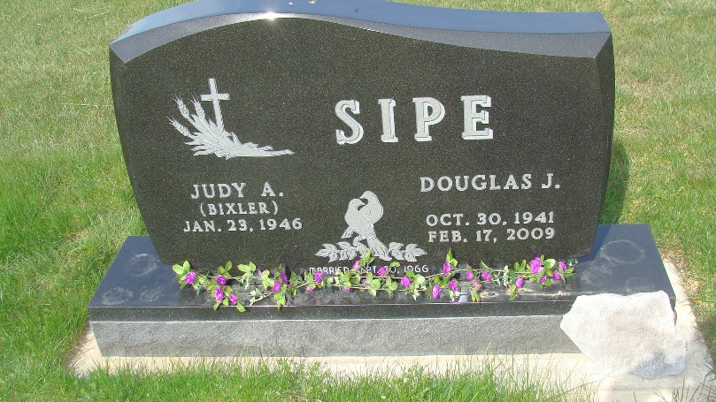
Photo by Alicia Kneuss

Douglas J. Sipe, 67, of Berne, Indiana passed away at 11:10 a.m. Tuesday, February 17, 2009 at his residence. Douglas was born on October 30, 1941 in Union City, Indiana the son of Ivan and Fern (Miller) Sipe, both deceased. He married Judy Bixler on September 30, 1966.
Douglas served in the United States Army National Guard for six years. He was an employee of New Idea Corporation of Coldwater, Ohio and retired from EPC of Geneva, Indiana after thirty-two years of service. Douglas enjoyed fishing, gardening, and sprint racing.
Douglas is survived by his wife, Judy Sipe of Berne, Indiana; a son, Bradley Sipe of Berne, Indiana; a daughter, Tammy (Jeffery) Bulmahn of Bryant, Indiana; a granddaughter, Krisa Sipe; a grandson, Noah Hirschy; and a great-granddaughter, Rook Shaver. Douglas was preceded in death by a brother, Richard Sipe.
Funeral services will be held at 10:00 a.m. Friday, February, 20, 2009 in the Yager Kirchhofer Funeral Home in Berne, Indiana with the Rev. Lou Destouet & John Fightmaster officiating. Interment will be in the M.R.E. Cemetery of rural Berne. Family and friends will be received from 2:00 – 8:00 p.m. Thursday, February 19, 2009 in the Yager-Kirchhofer Funeral Home and one hour prior to the service at the funeral home on Friday.
Preferred memorials are to Family Hospice of Northeast Indiana & Union Chapel, Bryant.

Yager-Kirchhofer Funeral Home, Adams County, Indiana

