Vincent Lee Simpkins
February 17, 1963 – May 6, 2022

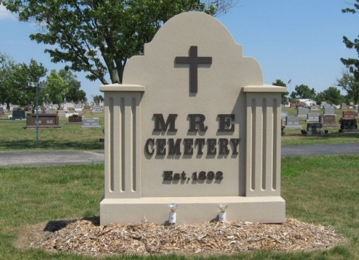
Photo by Tombstoner & Family

Vincent L. Simpkins, 59, of Pierceton, Indiana, passed away Friday, May 6, 2022, at Parkview Randallia Hospital in Fort Wayne, Indiana. He was born on February 17, 1963, in Marion, Indiana to the late Danny and Carol (Snyder) Simpkins. Vincent was united in marriage to Jennifer Hirschy on March 12, 1999, in Pierceton, Indiana.
He previously worked for the City of Warsaw, Indiana, at the Warsaw airport. He graduated from Adams Central High School class of 1982. Vincent was a handyman and mechanic. He loved helping his friends and neighbors and had a very big heart.
Survivors include his wife, Jennifer Simpkins of Pierceton, Indiana; sister, Tonya Simpkins of Jasper, Indiana; niece, Jessica (Joey) Birkle of Jasper, Indiana; mother-in-law, Anna Laura Hirschy, of Berne, Indiana; sister-in-law, Laura (Tom) Miller of Berne, Indiana; sister-in-law, Becky (David) Cox of Berne, Indiana; brother-in-law, Tim Hirschy of Decatur, Indiana; sister-in-law, Marsha (Tim) Broseke of Broken Arrow, Oklahoma; and a brother-in-law, Mark (Jeni) Hirschy of Berne, Indiana.
He was preceded in death by his daughter, Stephanie Simpkins; father-in-law, Richard H. Hirschy; sisters-in-law, Dr. Angela Hirschy, and Anita Hirschy.
A public graveside service will be held at 2:00 p.m. Friday, May 13, 2022, at the M.R.E. Cemetery in Berne with Pastor David Cox officiating.
Preferred memorials can be given to the family. (Checks payable to Zwick & Jahn Funeral Home and can be mailed to 520 N. 2nd. St., Decatur, IN 46733)

Zwick & Jahn Funeral Home, Adams County, Indiana

