Stephanie Rene Simpkins
November 4, 1982 – August 14, 2003

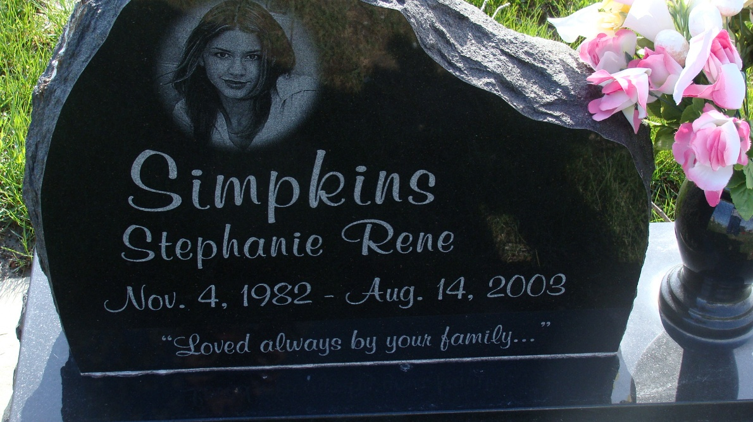
Photo by Alicia Kneuss

Indiana, U.S., Death Certificates, 1899-2017
Name Stephanie R Simpkins
Gender Female
Race White
Marital Status Single
Age 20
Birth Date 4 Nov 1982
Birth Place Jacksonville, Florida
Death Date 16 Aug 2003
Death Place Fort Wayne, Allen, Indiana, USA
Cause of death Manual strangulation
Death Registration Date 2003
Father Vincent Simpkins, informant
Mother Francela Swygart
Burial 8/21/2003 M.R.E.

