William Dean Simon
May 18, 1936 – December 9, 2020

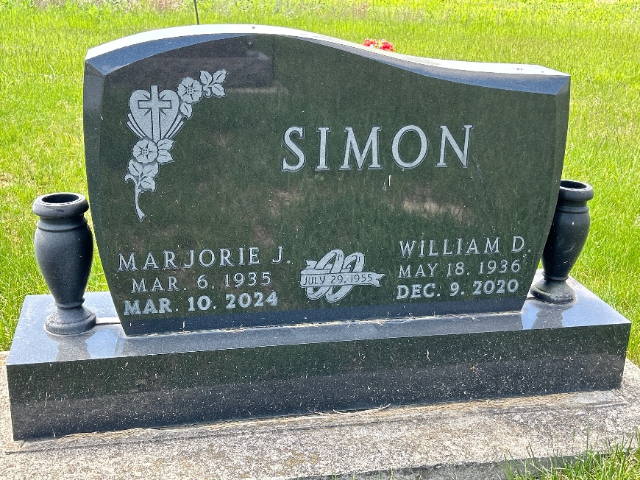
Photo by Barbara Baker Anderson

William Dean Simon, 84, of Berne passed away peacefully with his family by his side Wednesday, December 9, 2020, at 4:30 a.m. at his residence. He was born Monday, May 18, 1936, in Adams County to Arnold and Mary Jane (Lash) Simon. He was married Friday, July 29, 1955, in Berne to Marjorie Neuenschwander.
He served in the U.S. Navy Reserves. He attended Hartford Township School. He retired from Franklin Electric after 50 years of service. He had worked for Yager-Kirchhofer Funeral Home in Berne for 12 years and later joined the staff at Downing & Glancy Funeral Home in Geneva, where he served numerous families at their time of need. He attended West Missionary Church in Berne, where he was a very dedicated member and was also on the board. His ministry was to distribute God’s Promise Books to many families. He and his wife enjoyed taking golf cart rides to Willshire for ice cream, gardening and riding his helix motor scooter.
He is survived by his wife of Berne; daughter, Deborah J. (Timothy) Arnold of Linn Grove; son, Alan W. (Kathryn) Simon of Celina, Ohio; four grandchildren, Michael (Deborah) Arnold of Linn Grove; Jeff (Laura) Simon; and John Adair, both of Celina, Ohio; and Bob Simon of Geneva; and nine great-grandchildren, Bryce Arnold, Hannah Arnold, Courtney Arnold, Cassie Arnold and Britaney Arnold, all of Linn Grove; Bentley Simon and Lincoln Simon, both of Celina, Ohio; and Brayden Simon and Aubrey Simon, both of Geneva.
He was preceded in death by his parents; and six siblings, Victor Simon; Jim Simon; Martha Gifford; Leola Sprunger; Mablene Moser; and Verlin Smith.
Visitation will be Sunday, December 13 from 1-5 p.m. at Downing & Glancy Funeral Home, 100 N. Washington St., Geneva and one hour prior to the 10 a.m. funeral service Monday, December 14 at West Missionary Church, 4295W S.R. 218, Berne. Officiating will be Pastor Keith Rupp. Burial will be at MRE Cemetery in Berne. Due to the COVID-19 pandemic, everyone is asked to practice social distancing, and masks are recommended.
Memorials may be made to the West Missionary Benevolent Fund, 4295W S.R. 218 Berne, IN 46711. Arrangements provided by Downing & Glancy Funeral Home in Geneva. Online condolences may be made at www.glancyfuneralhomes.com.

The Berne Witness, Adams County, Indiana
December 11, 2020

