Victor A. Simon
February 2, 1910 – January 6, 1996

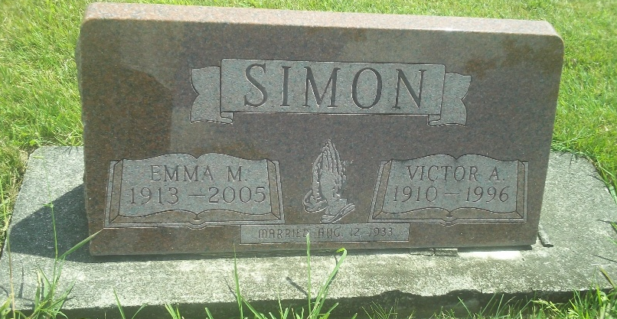
Photo by DSON1492

Victor A. Simon, 85, Berne, died at 8:45 p.m. Saturday in Caylor-Nickel Medical Center, Bluffton, of heart failure after having been ill for two weeks. He was a lifetime Adams county resident, born on Feb. 2, 1910 to Arnold and Flora Myers-Simon. He married Emma Rauch on Aug. 12, 1933; she survives.
He was a mechanic at Balsiger Motors in Berne for many years, then retired in 1990 after being self-employed as a mechanic. He was a member of Trinity United Methodist Church in Berne and was a church trustee.
Other survivors are a son, Larry Simon, Berne; a brother, William "Bill" Simon, rural Berne; a stepbrother, Gerald "Verlin" Smith, Monroeville; a stepsister, Mrs. Eugene (Mabeline) Moser, Bluffton; two grandchildren and seven great-grandchildren. A brother, James Simon, and two sisters, Leola Sprunger and Martha Gifford are deceased.
Funeral services will be at 10:30 a.m. Wednesday in Yager-Kirchhofer Funeral Home, Berne, with burial in MRE Cemetery, Berne. Visiting hours are 2-8 p.m. Tuesday and 8-10:30 a.m. Wednesday.
Preferred memorials are to the church or to The Gideons International.

Decatur Daily Democrat, Adams County, Indiana
Monday, Jan. 8, 1996

