Rosanna R. (Myers) Simon
January 5, 1921 - April 4, 2011

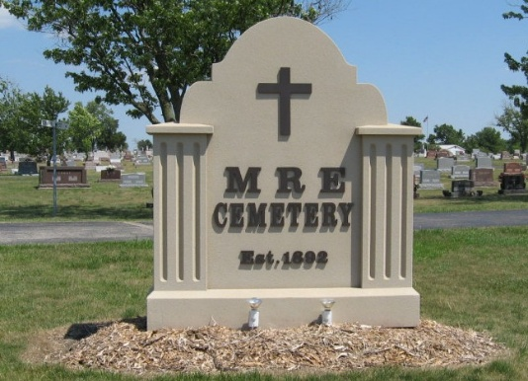
Photo by Tombstoner & Family

Rosanna R. Simon, 90, a resident of Berne, Indiana passed away at 1:25 a.m. Monday, April 4, 2011 at the Swiss Village Retirement Community in Berne. Rosanna was born on January 5, 1921 in Wells County, Indiana the daughter of George and Daisy (Isnogle) Myers, both deceased. She married James Simon on March 19, 1938 and he preceded her in death in 1975.
Rosanna was a member of the Trinity United Methodist Church in Berne. She was a twenty-five year former employee of Gifford’s IGA in Berne. She enjoyed crocheting doilies and traveling.
Rosanna is survived by a son, Gene E. (Jane) Simon of Liberty Center; a son, Rodney (Teresa) Simon of Decatur; a daughter, Carol (Jerry) Sommer of Berne; and a daughter, Nancy (Dan) Dellinger of Fort Wayne. Other survivors include fourteen grandchildren, twenty-eight great-grandchildren; and one great-great-grandchild.
Rosanna was preceded in death by a sister, Opal Kiefer and brothers, Charles, John, Ray, and Earl Myers.
Funeral services will be held at 10:30 a.m. Thursday, April 7, 2011 at the Trinity United Methodist Church in Berne with the Pastor Mark Harris officiating. Interment will be in the M.R.E. Cemetery of rural Berne. Family and friends will be received from 3:00 – 8:00 p.m. Wednesday, April 6, 2011 at the Swiss Village Chapel and one hour prior to the funeral service at the church on Thursday.
Preferred memorials are to Family Hospice of Northeast Indiana or the Swiss Village Endowment Fund.

Yager-Kirchhofer Funeral Home, Adams County, Indiana

