Mary Jane (Lash) Simon
May 25, 1897 – February 9, 1976

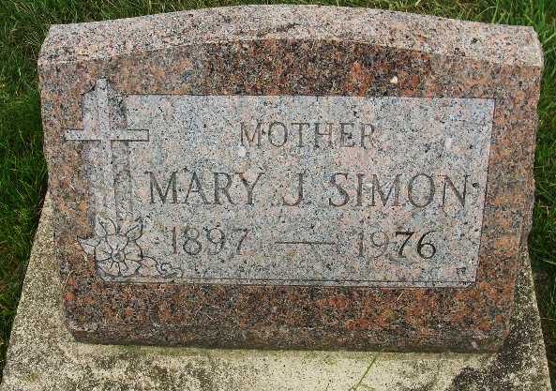
Photo by Alicia Kneuss

Indiana, U.S., Death Certificates, 1899-2017
Name Mary Simon
[Mary Lash]
Gender Female
Race White
Marital Status Widowed
Age 78
Birth Date 25 May 1897
Birth Place Indiana
Death Date 9 Feb 1976
Death Place Berne, Adams, Indiana, USA
Death Registration Date 1976
Father Andrew Lash
Mother Sarah Kleinknight
Informant William D. Simon, son
Burial M.R.E. 2/12/1976

