Marjorie Joan (Neuenschwander) Simon
March 6, 1935 – March 10, 2024

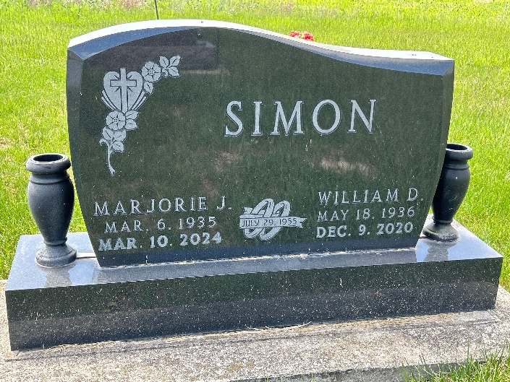
Photo by Barbara Baker Anderson

Marjorie Joan Simon, 89, of rural Berne passed away Sunday, March 10, 2024, at 5:40 p.m. at her home surrounded by family. She was born Tuesday, March 6, 1935, to Joel and Cora (Winteregg) Neuenschwander of Berne. She was married July 29, 1955, at the First Mennonite Church in Berne to William “Bill” Simon.
She was a 1955 graduate of Geneva High School where she was a cheerleader and a member of 4-H. She worked at her family’s business, The Berne Locker Storage, along with her father, brothers and nephews.
She is survived by her daughter, Debbie (the late Tim) Arnold of rural Berne; and Alan (Kathy) Simon of Celina, Ohio; three grandsons, Michael (Deborah) Arnold of Linn Grove; Jeff (Laura) Simon of Celina, Ohio; and Robert (Courtney) Simon of rural Geneva; 12 great-grandchildren, Hannah, Courtney, Cassidy, Bryce and Brittney Arnold; and Bentley, Lincoln, Aubrey, Brayden, Raigan, Carter and Johnny Simon; and adopted grandson, Jon Adair.
She was preceded in death by her parents; her husband; three brothers, Sherman, Delmar and LeDale Neuenschwander; and five sisters, Vergene Yake; Flo Dynes; Romona Schwartz; Elly Schindler; and Willie Luginbill.
Visitation will be Saturday, March 16 two hours prior to the 2 p.m. celebration of life service at West Missionary Church, 4295 W. S.R. 218, Berne. Officiating will be Pastor Keith Rupp. Burial will be at MRE Cemetery in Berne.
Memorials may be made to the West Missionary Church children’s department, 4295 W. S.R. 218, Berne.
Arrangements provided by Downing & Glancy Funeral Home in Geneva.

The Berne Witness, Adams County, Indiana
March 13, 2024

