Larry Lee Simon
April 30, 1938 – February 18, 2017

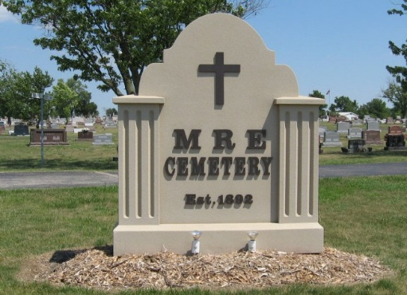
Photo by Tombstoner & Family

Larry L. Simon, 78, Berne. well known businessman passed away February 18, 2017 at Lutheran Hospital, Fort Wayne. He was born to Victor and Emma Rauch Simon on April 30, 1938 in Adams County, IN. He married Gail Brewster on October 11, 1959.
Larry was a member of the First Mennonite Church where he ran the sound system for many years. He was a former employee of Berne Electric and in 1977 formed L&L Electric a partnership with Les Augsburger. Later be became sole owner of the company and specialized in industrial electrical work for over 38 years.
The family spent many years enjoying activities on Dallas Lake. Upon retirement the couple lived on Dallas Lake for 12 years and recently returned to Berne. Special interests include; fishing, following the U Conn girls basketball team, racing his speed boat on his favorite lake, and following his grandchildren's sporting activities.
Survivors include; his wife, Gail, son, Mitchel(Tracy)Simon of Berne, daughter, Victoria (Rex) Myers of Berne, 6 grandchildren, and 7 great-grandchildren. Preceding in death are his parents and grandson, Adam Simon.
Memorial service is Saturday, February 25, 2017 at 10:30 am at the First Mennonite Church Chapel with visitation 1 hour prior to the service. Visitation also Friday, 24th from 3 to 8 pm at the Yager-Kirchhofer Funeral Home, Berne. Officiating is Pastor Jerry A. Flueckiger, Burial at the MRE Cemetery, Berne.
Preferred memorials to MCC Meat Canner, First Mennonite Church.

Zwick & Jahn Funeral Home, Adams County, Indiana

