James Myers Simon
March 17, 1916 – July 17, 1975

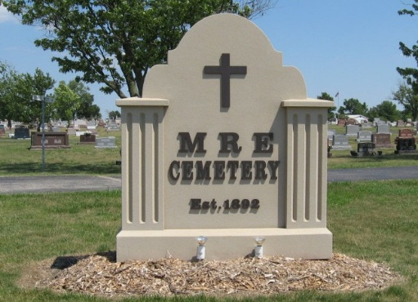
Photo by Tombstoner & Family

Indiana, U.S., Death Certificates, 1899-2017
Name James Simon
Gender Male
Race White
Marital Status Married
Age 54
Birth Date 17 Mar 1916
Birth Place Indiana
Death Date 17 Jul 1975
Death Place Berne, Adams, Indiana, USA
Death Registration Date 1975
Father Arnold Simon
Mother Flora Myers
Spouse Rosanna Myers Simon, informant
Burial M.R.E. 7/19/1975

