Frank Simon
April 3, 1916 – June 27, 1980
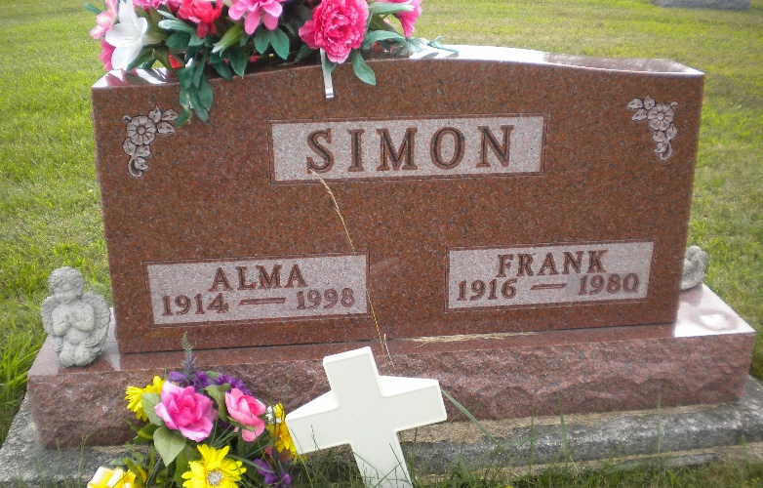
Photo by DSON1492

Indiana, U.S., Death Certificates, 1899-2017
Name Frank Simon
Gender Male
Race White
Marital Status Married
Age 64
Birth Date 3 Apr 1916
Birth Place Indiana
Death Date 27 Jun 1980
Death Place Bluffton, Wells, Indiana, USA
Death Registration Date 1980
Father David Simon
Mother A Bertha Kuntz
Spouse Alma Stewart Simon, informant
Burial M.R.E. 7/1/1980

