Emma M. (Rauch) Simon
June 11, 1913 – November 5, 2005

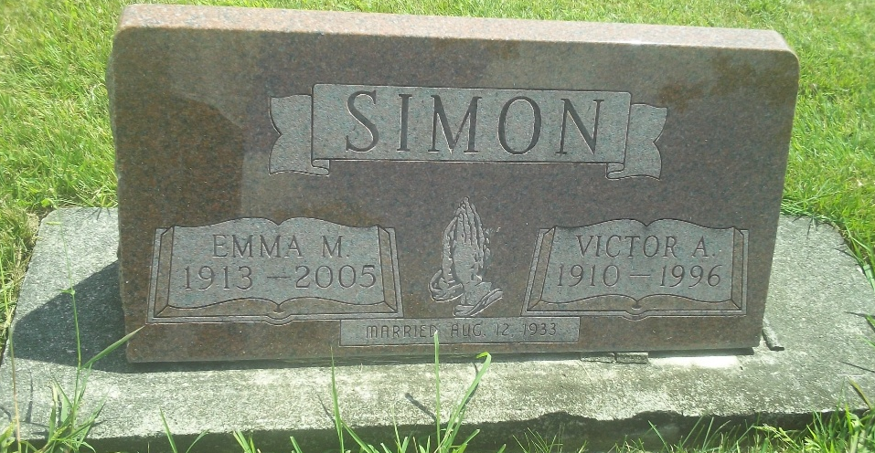
Photo by DSON1492

Emma M. Simon, 92, of Swiss Village at Berne died Saturday, Nov. 5, 2005, at Bluffton Regional Medical Center. A homemaker, Mrs. Simon was born June 11, 1913, in Wells County to Godfrey and Elizabeth Minger Rauch. She was married Aug. 12, 1933, in Berne to Victor Simon, who preceded her in death in 1996. Mrs. Simon was a member of Trinity United Methodist Church.
Survivors include a son, Larry Simon of Wolcottville; two grandchildren; and seven great-grandchildren.
She was preceded in death by sisters Leah Bertsch, Lena Christener, Frieda Lehman and Hilda Steffen; and brothers Jay, Calvin, Alfred, Jeff and Irvin Rauch.
Services will be 10:30 a.m. Wednesday at Yager-Kirchhofer Funeral Home, Berne, with Rev. Craig Maven officiating. Calling is from 4 to 8 p.m. Tuesday and one hour prior to services Wednesday at the funeral home. Burial will be in M.R.E. Cemetery.
Preferred memorials are to Trinity United Methodist Church Missions or Gideons International.

News Banner, Bluffton, Wells County, Indiana
Nov. 8, 2005

