E. Lucile (McMichael) Simon
September 15, 1914 – July 14, 2005

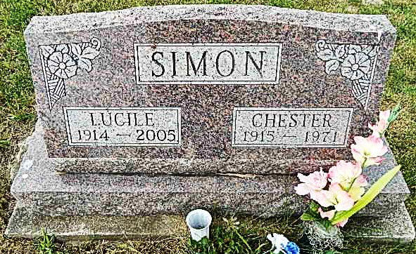
Photo by Alicia Kneuss

E. LUCILE SIMON, 90, of Berne, died Thursday, July 14, 2005, at Swiss Village, Berne. Born Sept. 15, 1914, in Henry County, Ind., she was married to Chester Simon on Aug. 19, 1933. She was a member of the former Missionary Church and a previous member of the Root Township Home Ec. Club.
Survived by son, Dallas H. Simon of Kokomo; seven grandchildren; 18 great-grandchildren; and one great-great-grandson; She was preceded in death by her parents, William W. and Effie E. (Harvey) McMichael; husband, Chester; and son, Ted W. Simon, in 2002.
Service is 10 a.m. Monday at Haggard & Sefton Funeral Home, Decatur. The Rev. Mark Beers officiating. Calling is from 12 to 2 p.m. Sunday at the funeral home. Burial at M.R.E. Cemetery, Berne.
Memorials to Swiss Village or Arthritis Foundation. To sign our guest book, click on www.haggardandsefton.com.

News-Sentinel, The (Allen County, Indiana)
Saturday, July 16, 2005

