Alma (Stewart) Simon
December 1, 1914 – June 6, 1998
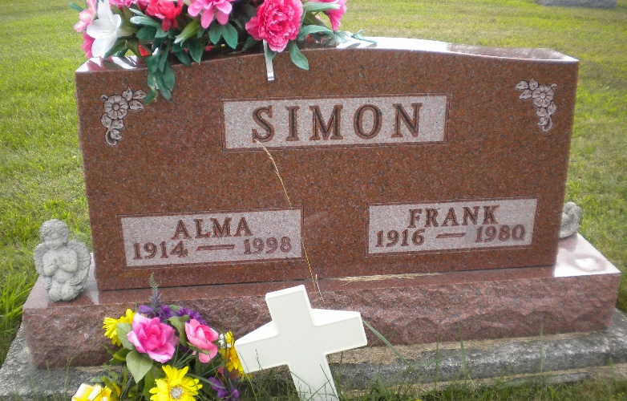
Photo by DSON1492

Indiana, U.S., Death Certificates, 1899-2017
Name Alma Simon
[Alma Stewart]
Gender Female
Race White
Marital Status Widowed
Age 83
Birth Date 1 Dec 1914
Birth Place Hamilton County
Death Date 6 Jun 1998
Death Place Berne, Adams, Indiana, USA
Death Registration Date 1998
Father Earl Stewart
Mother Inez Harvey
Informant Wilma Jean Crandall, daughter
Burial 6/9/1998 M.R.E.

