Samuel Siegrist
April 10, 1853 – August 10, 1942

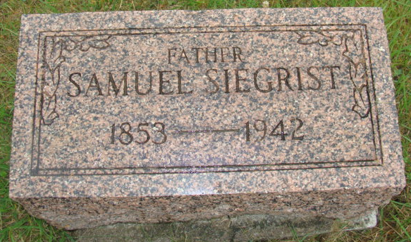
Photos by Alicia Kneuss

Samuel Siegrist
Mr. Siegrist, retired farmer, died early this morning at his home here. He was 89 years old.
Adams County, Indiana Historical Museum
1942Feb-Nov Scrapbook, Image 10
Handwritten-Mo. Aug. 10, 1942
**
SAMUEL SIEGRIST DIES HERE TODAY AT AGE OF 89
Rites Wednesday for Retired Farmer and Wagon Maker
Samuel Siegrist, 89, prominent retired farmer and wagon maker, died at his home at 318 East Main Street at 6:25 o'clock this morning following an illness of several weeks. Mr. Siegrist was one of Berne's oldest citizens and was widely known. Death was caused by heart disease, according to the attending physician. He had been bedfast for the past several weeks and seriously ill the last week.
Mr. Siegrist was a native of Canton Bern, Switzerland, where he was born on April 10, 1853. He came to this country in April of 1873, when he was a young man of 20. The family first settled at Sandusky, Ohio, then moved to Fort Wayne and later to Vera Cruz. At Vera Cruz, Mr. Siegrist manufactured wagons, a trade of which he continued for several years. Later (missing) and moved to Berne with his wife on October 15, 1911. They resided here since.
Mr. Siegrist was married to Elizabeth Bischoff, also a native of Switzerland, on November 11, 1880. They were married at Vera Cruz by the late Rev. George Roederer, father of Rev. I.G. Roederer, former local pastor. The couple celebrated their Golden Wedding anniversary on November 11, 1940. Mrs. Siegrist, who was born March 27, 1862, survives, together with a daughter, Mrs. Gerhart Steiner of Berne.
One niece resides in Switzerland. Eight grandchildren and four great-grandchildren survive. The parents and five children preceded. The children were Albert, Mrs. Nettie Miller, Gottfried, Samuel and Frank.
Mr. Siegrist was a member of the Mennonite Church. The funeral will be held Wednesday afternoon at 2:00 o'clock at the church, following a short service at the home. Rev. N.J. Schmucker will officiate, assisted by Rev. George G. Holston. Burial will be in the M.R. E. Cemetery.
Adams County, Indiana Historical Museum
1942Feb-Nov Scrapbook, Image 145
Handwritten-Mon. Aug. 10, 1942

