Samuel Siegrist
December 14, 1885 – July 8, 1900

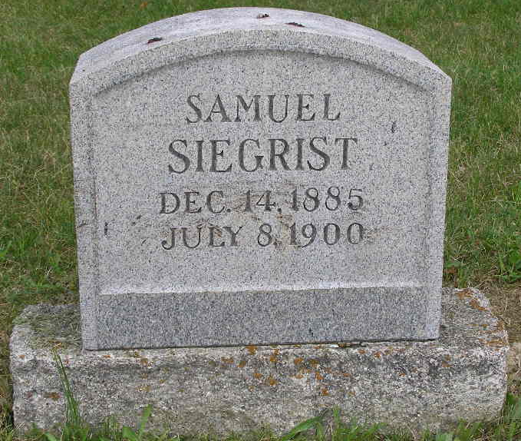
Photo by Shaunda Bedwell Opdycke

Indiana, U.S., Death Certificates, 1899-2017
Name Samuel Siegrist
Gender Male
Race White
Age 14y 6m 22d
Cause of death Consumption; had no physician
Birth Date abt 1886
Birth Place Meads Co, Indiana
Death Date 8 Jul 1900
Death Place French, Adams, Indiana, USA
Death Registration Date 1899-1900
Father Samuel Siegrist b. Germany, informant
Mother Elisabeth Segrist b. Switzerland
Burial M.R.E. Cemetery 7/11/1900

