Melita (Wulliman) Siegrist
August 19, 1888 – April 5, 1969

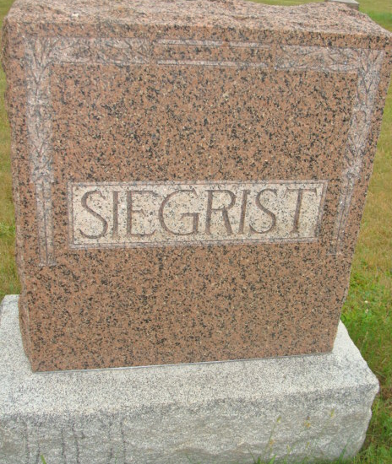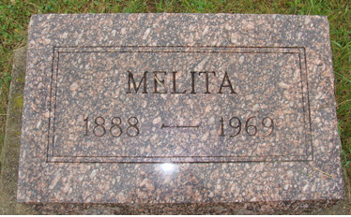
Photos by Alicia Kneuss

Mrs. Melita Siegrist, 80, Dies Saturday
Funeral Will be Held Tuesday, 2 pm

Mrs. Melita (Frank) Siegrist, 80, died at 5:15 PM Saturday at the Adams County Memorial Hospital in Decatur. She had been in failing health for some time and was hospitalized March 11 being moved there from Swiss Village, Incorporated. The deceased lived with her daughter and son-in-law, Mr. and Mrs. Ezra Amstutz, Kidron, Ohio, for over a year prior to entering Swiss Village here.
Mrs. Siegrist was the daughter of Jacob Wulliman and Katherine Neuenschwander, and was born in French Township, August 19, 1888. Her marriage to Frank Siegrist, who preceded her in 1922, took place, October 15, 1911.
Surviving are a daughter, Mrs. Ezra (Katherine) Amstutz, Kidron, Ohio, and the son-in-law Ezra E. Amstutz. Preceding were Noah, William, Levi, David, Mennas, and Mrs. Anna Augsburger, Lydia Wulliman and Caroline Chappius.
Viewing will be after 3 PM today at the Yager Funeral Home, where services will be held on Tuesday at 2 PM with the Rev. Gordon Neuenschwander officiating. She was a faithful member of the First Mennonite church. Burial is in the MRE Cemetery.

Date of Death: Saturday, April 5, 1969 Date of Burial: April 8, 1969 Burial: MRE – Lot 366 – Original Platt

Berne (IN) Public Library Heritage Room
MRE Obit Scrapbook

