Franklin Siegrist
September 26, 1889 – November 5, 1922

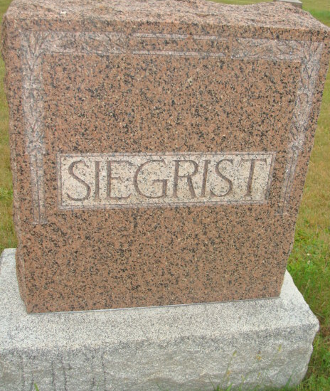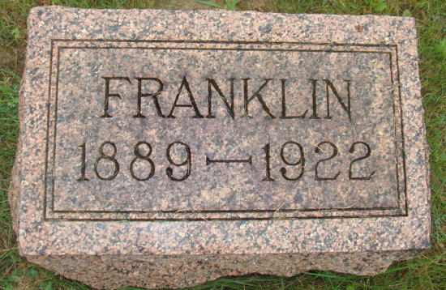
Photos by Alicia Kneuss

FARMER VICTIM OF PNEUMONIA
Frank Siegrist, Of French Township, Died Early Sunday Morning

Frank Siegrist, age 33 years, well, known farmer of French Township, living 6 ½ miles northwest of Berne, died Sunday morning at 4:20 at his home. The death of Mr. Siegrist came as a great shock to the community, as few people had known of his serious illness. Death was due to pneumonia from which he suffered intensely during his short illness.
Mr. Siegrist had been in Berne only last Wednesday to transact some business matters. He had already felt sick that day, but was not severely sick until that evening. His condition kept growing worse until Friday night when he suffered a bad spell. He had another bad spell Saturday morning and kept declining, until death relieved him early Sunday morning.
Frank Siegrist was born in Vera Cruz. Ind., on September 26, 1889. His life was spent near Vera Cruz and on the farm in French Township. On October 15, 1911, he was married to Miss Melitta Wulliman. Since that time, they have been living on his father's farm in French Township. One child was born to this union, a daughter, Catherine. Mrs. Siegrist and her daughter both survive the deceased.
Besides his wife and child, Mr. Siegrist leaves to mourn his departure his parents, Mr. and Mrs. Sam Siegrist, and one sister, Mrs. Gerhard Steiner of Berne. Besides these, a number of friends and other relatives are left. Three brothers and one sister have preceded him in death.
Funeral services will be held at the home at 9 o'clock Wednesday morning and at 10 o'clock at the Mennonite Church in Berne. Burial will be made in the M. R. E. Cemetery.

Decatur Daily Democrat, Adams County, Indiana
Tuesday, November 7, 1922

