Elizabeth (Bischoff) Siegrist
March 27, 1862 – December 20, 1946

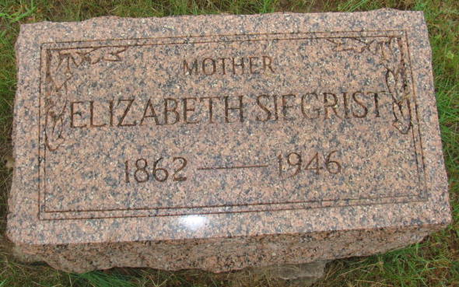
Photo by Alicia Kneuss

WIDOW OF SAMUEL SIEGRIST DIES LATE THURSDAY
Rites Sunday for Well Known 84-Year-Old Local Woman

Elizabeth Bischoff Siegrist, 84, widow of the late Samuel Siegrist, died Thursday evening at 9:15 o'clock at her home on East Main Street. She had been bedfast since September from complications and had ailed previously. Mrs. Siegrist had resided in Berne for the past 35 years.
The deceased was born March 27, 1862, in Switzerland, the daughter of John and Elizabeth Michael Bischoff. She came to this country when a young girl and on November 11, 1880, she was married to Samuel Siegrist. He preceded in death August 10, 1942. The couple lived on a farm I French Township for many years before moving to Berne about 1910.
Mrs. Siegrist had suffered from hardening of the arteries and complications for a long time. Her condition was not critical until late Wednesday when some form of pneumonia developed and hastened her death.
Surviving is a daughter, Mrs. Gerhart (Esther) Steiner of Berne; two sisters, Mrs. Jonas Neuenschwander of Vera Cruz and Mrs. Jeff Neuenschwander of Woodburn; two half-sisters, Mrs. Henry Schepelman, Wabash and Mrs. Paul Scherschel of New Haven; one granddaughter and one step-grandchild.
Two sons, Frank and Samuel, two step-children, Albert and Annetta, four brothers, John, Ulrich, Crist and one in infancy, and a half-sister, Rosa, preceded in death in addition to the husband and parents.
Mrs. Siegrist was a member of the First Mennonite Church. The funeral will be held at the church Sunday at 3:00 p.m. with the Rev. Olin Krehbiel officiating. Burial will be in the M. R. E. Cemetery. Friends may view the body at the Yager Funeral Home after Saturday morning.

Adams County, Indiana Historical Museum
Scrapbook " 1946Sep-Dec" Image 109
Handwritten-Fri. Dec. 20, 1946
**
Indiana, Death Certificates, 1899-2011
Name Elizabeth Bischoff Siegrist
[Elizabeth Bischoff Bischoff]
Gender Female
Race White
Age 84y 8m 22d
Marital Status Widowed
Birth Date 27 Mar 1862
Birth Place Switzerland
Death Date 20 Dec 1946
Death Place Berne, Adams, Indiana, USA
Death Registration Date 1946
Father John Bischoff b. Switzerland
Mother Elizabeth Michael b. Switzerland
Spouse Samuel Siegrist
Informant Mrs. Esther Steiner
Burial M. R. E. 12-22-1946

