Adolph Siegrist
August 9, 1853 – March 20, 1932

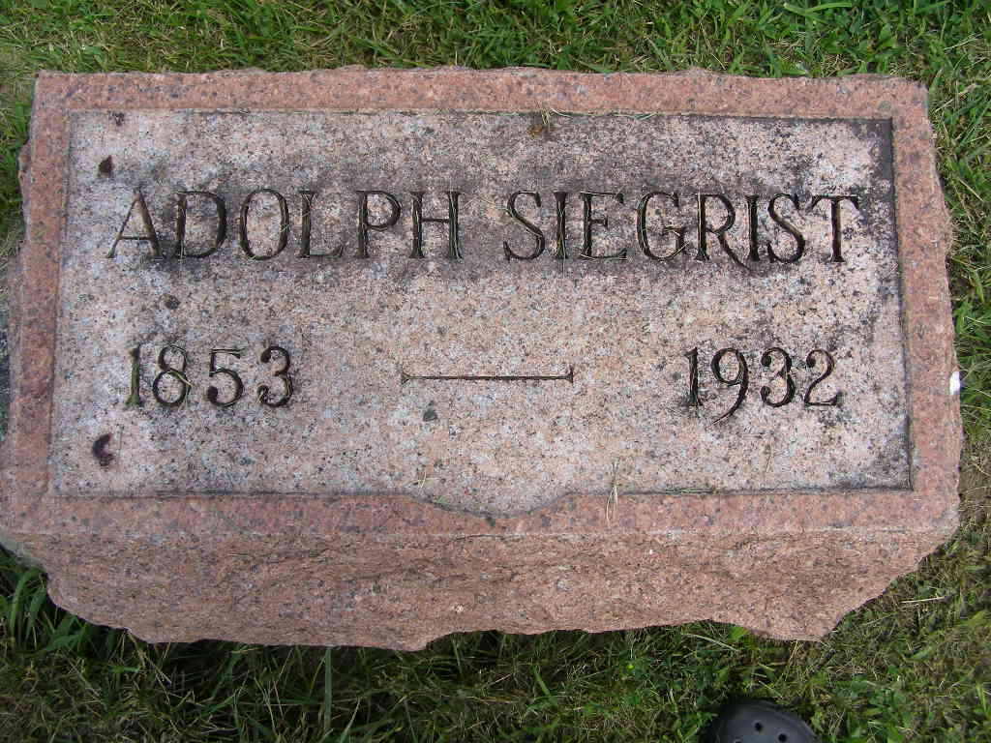
Photo by Shaunda Bedwell Opdycke

Indiana, U.S., Death Certificates, 1899-2017
Name Adolph Siegrist
Gender Male
Race White
Marital Status Married
Age 78y 7m 11d
Birth Date 9 Aug 1853
Birth Place Switzerland
Death Date 20 Mar 1932
Death Place Washington, Adams, Indiana, USA
Death Registration Date 1932
Father Christian Siegrist b. Switzerland
Mother unknown b. Switzerland
Informant Mrs. Emma Reusser
Burial M.R.E. Cem 3-23-1932

