Rose D. (Pyle) Shoemaker
May 4, 1864 – March 14, 1957

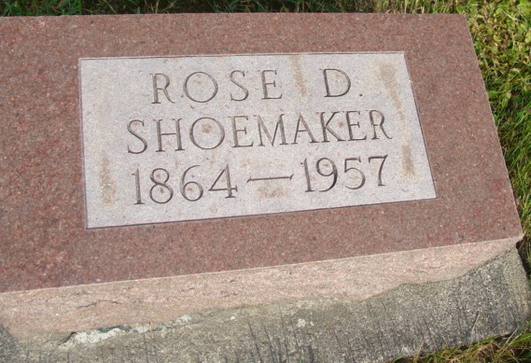
Photo by Alicia Kneuss

WIDOW OF GEORGE SHOEMAKER SUCCUMBS
FUNERAL AT GENEVA ON SATURDAY FOR 91-YEAR-OLD WOMAN
Mrs. Rosa D. Shoemaker, 91, residing approximately five miles northwest of Geneva, died about 10 a.m. Thursday in the Adams County Memorial Hospital, Decatur, where she had been a patient two weeks. She had been in failing health several years.
Mrs. Shoemaker was a lifelong resident of the Geneva community. She was born in Geneva May 4, 1864, the daughter of George and Saluda Butcher Pyle. Her husband preceded in death in 1941.
Surviving are a daughter, Mrs. Opal Duhane, near Geneva; three sons, Andrew Shoemaker of Ottumwa, Ia., Wilbur Shoemaker, Red. Oak, Ia., and Guy Shoemaker, near here; four grandchildren, seven great-grandchildren and a brother, Curry S. Pyle, Lake Hamilton, Fla.
Mrs. Shoemaker was a member of the Geneva Evangelical United Brethren Church.
The body is at the Hardy & Hardy Funeral Home in Geneva where friends may call. Services will be conducted at 2 p.m. Saturday in the funeral home with the Rev. A.B. McKain, pastor of the church, officiating. Burial will be in the MRE Cemetery, Berne.
Adams County (IN) Historical Museum
1955 Mar-April 1958 Scrapbook
Handwritten-Fri. March 15, 1957

