Paul Watt Shoemaker
August 16, 1901 – May 14, 1975

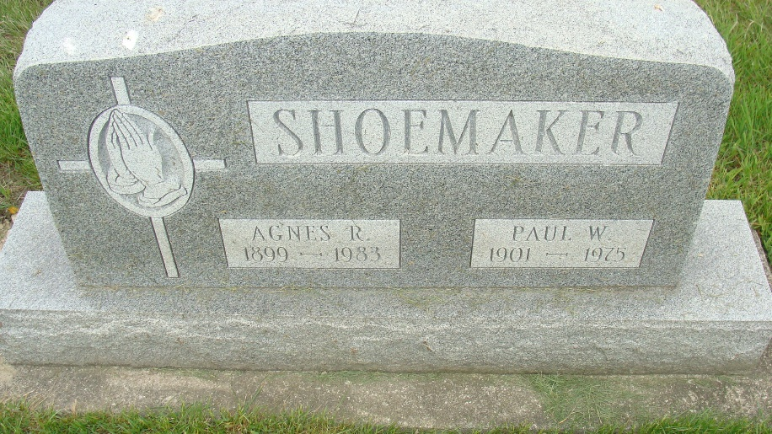
Photo by Alicia Kneuss

Paul Watt Shoemaker, 73, of route 1, Berne, a retired machinist, died at 5 a.m. this morning at his residence.
A woods near his home served as a wildlife sanctuary and Mr. Shoemaker was a member of the Berne Conservation club. He was also a member of the Gospel Businessmen’s Association International. Mr. Shoemaker was a member of the Berne Church of the Nazarene.
Born in Poneto on August 16, 1901, he was the son of Samuel A. and Mary Watt Shoemaker, and was united in marriage on March 8, 1925 in Berne to Agnes R. Atz, who survives.
Other survivors include one daughter, Mrs. George F. (Lillian) Reusser, of Punta Gorda, Belize, Central America; nine grandchildren and one great-child. One son, James, died in a car accident in 1951, and one sister preceded him in death.
Funeral services will be held at 10 a.m. Saturday at the Yager funeral home, with Rev. Darwin L. Pressler and Rev. Richard N. Zulauf officiating. Burial will be in the MRE cemetery. Friends may call at the funeral home after 7 p.m. Thursday.
Preferred memorials are to missions.

Decatur Daily Democrat, Adams County, Indiana
Wednesday, May 14, 1975
**
Indiana, U.S., Death Certificates, 1899-2017
Name Paul Watt Shoemaker
Gender Male
Race White
Marital Status Married
Age 73
Birth Date 16 Aug 1901
Birth Place Indiana
Death Date 14 May 1975
Death Place Berne, Adams, Indiana, USA
Death Registration Date 1975
Father Samuel A. Shoemaker
Mother Mary Watt
Spouse Agnes R. Atz Shoemaker, informant
Burial M.R.E. 5/17/1975

