James Watt Shoemaker
April 5, 1930 - July 9, 1951

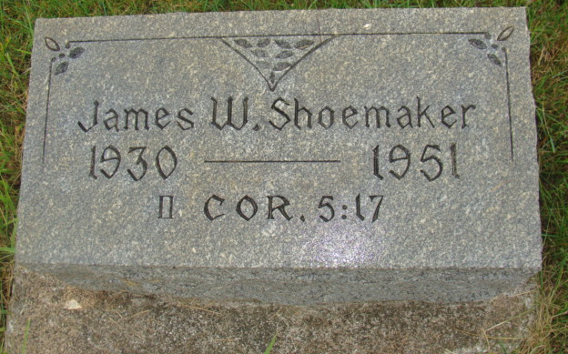
Photo by Alicia Kneuss

Indiana, U.S., Death Certificates, 1899-2017
Name James Shoemacker
Gender Male
Race White
Marital Status Never Married (Single)
Age 21
Birth Date 5 Apr Abt 1930
Birth Place Indiana
Death Date 9 Jul 1951
Death Place Fort Wayne, Allen, Indiana, USA
Cause of death auto accident
Death Registration Date 1951
Father Paul Shoemacker
Mother Agnes Atz
Informant L. Luther Yager
Burial MRE 7/11/1951
**
Indiana, U.S., Birth Certificates, 1907-1944
Name James Watt Shoemaker
Gender Male
Birth Date 5 Apr 1930
Birth Place Berne, Adams, Indiana, USA
Father Paul Shoemaker
Mother Agnes Atz
Certificate Number 14947
Roll number 40474_356500
Volume Range 26 - 30

