George Shoemaker
April 19, 1862 – October 16, 1941

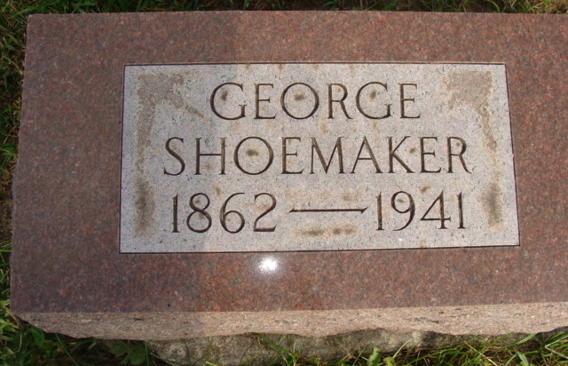
Photo by Alicia Kneuss

Indiana, U.S., Death Certificates, 1899-2017
Name George Shoemaker
Gender Male
Race White
Marital Status Married
Age 79y 5m 27d
Birth Date 19 Apr 1862
Birth Place Adams County, Indiana
Death Date 16 Oct 1941
Death Place Rural, Adams, Indiana, USA
Death Registration Date 1941
Father Jacob Shoemaker
Mother Catherine Baker
Spouse Rosa D Pyle Shoemaker, age 77
Informant Mrs. Geo. Shoemaker
Burial M.R.E. 10-19-1941

