Alice Elizabeth (Roth) Shoemaker
March 24, 1923 – July 29, 2019

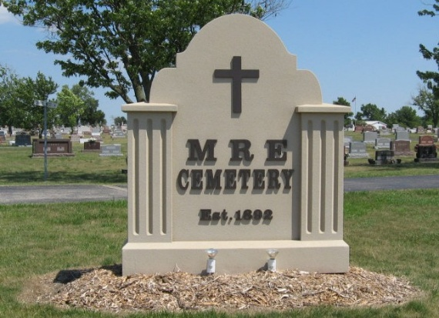
Photo by Tombstoner & Family

Alice Elizabeth Shoemaker, 96, of Decatur, Indiana passed away on Monday, July 29, 2019 at Adams Woodcrest. She was born on March 24, 1923 in Decatur, Indiana to the late Noah W. and Rufine (Beer) Roth. On May 28, 1966 she married Robert E. Shoemaker.
Alice worked in the office at Central Soya for 20 years and for Indiana Michigan & Electric Company for 21 years. Alice was a lifelong resident of Adams County and a member of Zion United Church of Christ where she was involved in the Women's Guild, sang in the choir, and was a Sunday School Teacher and President of the Friendship Circle.
Surviving is her husband of 53 years Robert Shoemaker and one brother LaVern "Chick" (Donna) Roth of Decatur, IN. She was preceded in death by her parents and one sister Vera Neaderhouser.
Visitation will take place on Saturday, August 3, 2019 from 11:00 am to 1:00 p.m. at Zion United Church of Christ with the funeral service beginning at 1:00 pm. The Graveside Service will follow at the M.R.E. Cemetery in Berne, IN with Rev. Randy Rossman officiating.
Memorials may be given to the Zion United Church of Christ.
Haggard & Sefton Funeral Home, Adams County, Indiana​
Tuesday, July 30, 2019

