Agnes R. (Atz) Shoemaker
December 1, 1899 – May 18, 1983

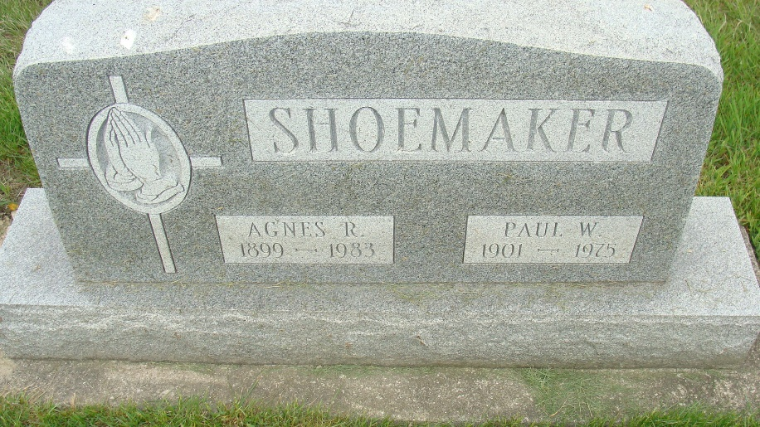
Photo by Alicia Kneuss

Indiana, U.S., Death Certificates, 1899-2017
Name Agnes R. Shoemaker
[Agnes R. Atz]
Gender Female
Race White
Marital Status Widowed
Age 83
Birth Date 1 Dec 1899
Birth Place Indiana
Death Date 18 May 1983
Death Place Berne, Adams, Indiana, USA
Death Registration Date 1983
Father Levi Atz
Mother Lillian Ashbaucher
Informant Mrs. George Reusser
Burial M.R.E. 5/21/1983

