Althea R. (Wulliman) Shoaf
July 9, 1945 – March 8, 1991

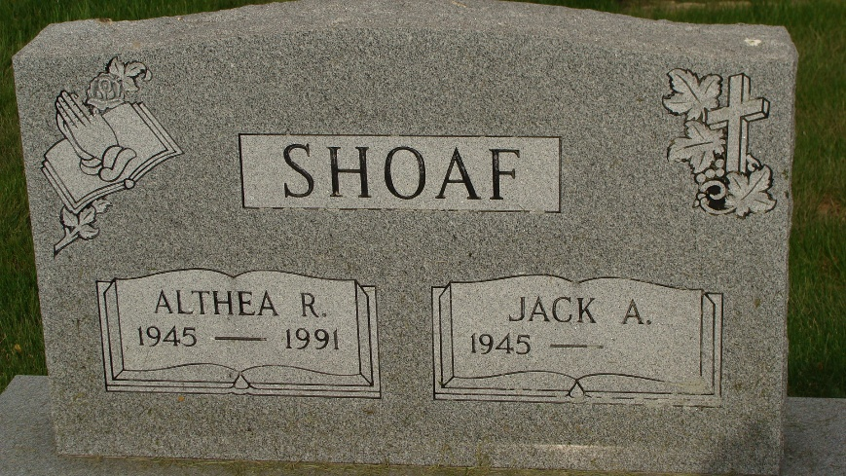
Photo by Alicia Kneuss

Indiana, U.S., Death Certificates, 1899-2017
Name Althea R Shoaf
Gender Female
Race White
Marital Status Married
Age 45
Birth Date 9 Jul 1945
Birth Place Decatur, Indiana
Death Date 8 Mar 1991
Death Place Bluffton, Wells, Indiana, USA
Death Registration Date 1991
Father Charles Wulliman
Mother Lavon Lehman
Spouse Jack Shoaf, informant
Burial 3/11/1991 M.R.E. Cemetery

