Virginia Mae (Grieser) Shively
June 23, 1924 – July 27, 2015

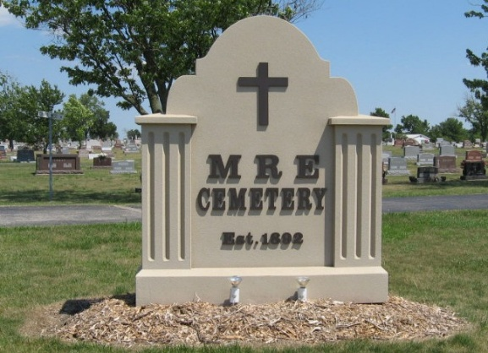
Photo by Tombstoner & Family

VIRGINIA MAE SHIVELY, 91, of Fort Wayne, formerly of Jenera, Ohio, passed away on Monday, July 27, 2015, 3:38 a.m., at Parkview Regional Center, Fort Wayne. Born June 23, 1924, in Van Buren Township, she was a daughter of the late Alva and Eva (Essinger) Grieser. She married Milo C. Lehman, then Dale Shively, both deceased.
She was an accomplished seamstress, and in the 1940's worked at Wayne Knitting Mill, she was a member of Emmaus Lutheran Church and the Ladies Aid Society of Immanual Lutheran Church, both in Fort Wayne, enjoyed crafts and loved being a grandma.
Surviving are daughter, Kathleen Bertholf of Fort Wayne; stepson, James (Sandy) Shively of West Liberty, Ky.; stepdaughter, Helen Trout of Fort Wayne: brothers, Robert (Barb) Grieser of Colorado and Eugene (Carol) Grieser of Jenera; sisters, Leora Grostick of Tacoma, Wash. and Carolyn Neerman of Shreveport, La.; grandchildren, Christopher and Kendall Berthoff; and a great granddaughter is expected in October.
She was also preceded in death by son-in-law, Charles Bertholf; daughter-in-law, Mary Lowery; brothers, Luther, Paul, Wendell, and Donald Grieser; sisters, Florence Bakle and Edith Wilson; and grandson; Andrew Bertholf.
Funeral service is 2 p.m. Monday, Aug. 3, 2015, at St. Paul Evangelical Church, with visitation two hours prior. Arrangements by Crates Funeral Home, Arlington. Memorials may be given to the family. Online condolences are welcomed at www.coldrencrates.com

Fort Wayne Newspapers, Allen County, Indiana
Jul. 30, 2015

