Mary (Gottschalk) Shigley
October 23, 1836 – May 19, 1922

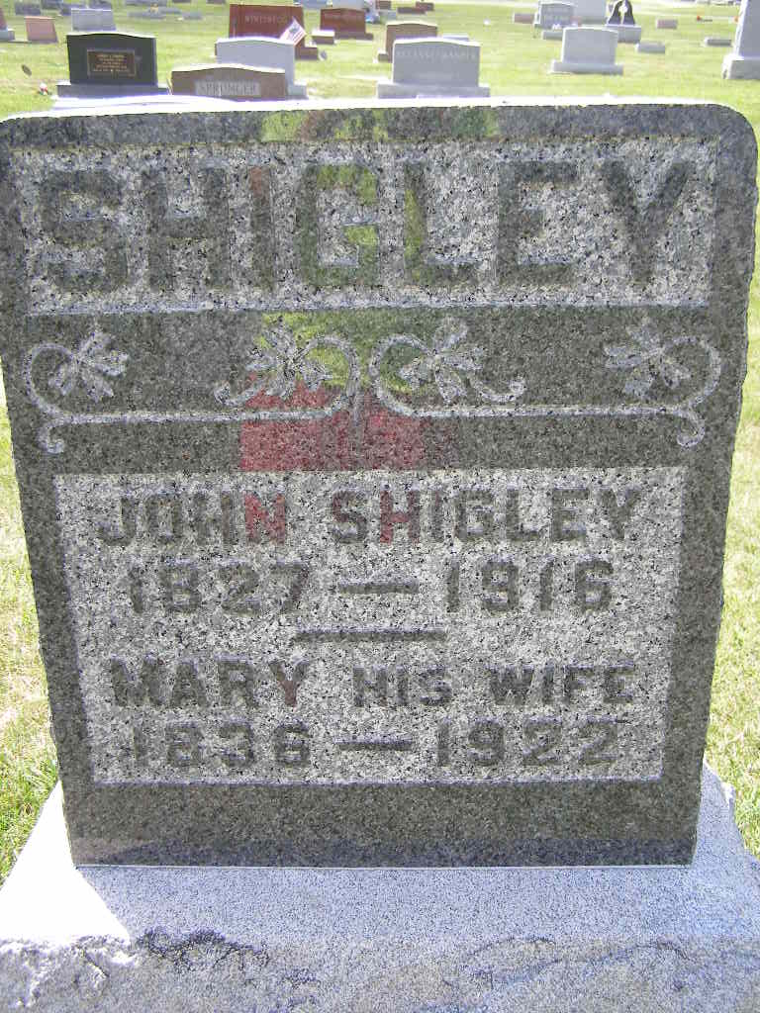
Photo by Shaunda Bedwell Opdycke

MARY SHIGLEY DIED AT SON'S HOME IN BERNE
Well Known Resident of This County Expired Friday at Age of 85
BORN IN GERMANY
Made Trip to America in a Sail Boat with Parents When A Child

Mrs. Mary Shigley, age 85 years, died at the home of her son, J. M. Rose in Berne, at 5:30 o'clock Friday evening, following an illness with infirmities of old age, hardening of the arteries and high blood pressure. Mrs. Shigley fell down a flight of steps last Wednesday and it is thought that injuries sustained in the fall hastened her death.
Mrs. Shigley was born in Wurtenburg, Germany, on October 3, 1836. She came to America when three and one-half years old and lived with her parents on a farm in Wells County for twenty-three years, before moving to Berne. The trip across the Atlantic was made in a sail boat and a period of ninety-three days was required to complete the voyage. Mrs. Shigley's maiden name was Mary Gottschalk.
On March 6, 1856, the deceased was married to Peter Rose. To this union the following children were born: George Rose, of Nebraska; Jacob P. Rose, of Wells County; Barbara Rose and J. M. Rose, of Berne. Mr. Rose died while in the service of his country during the Civil War in Nashville, Tennessee on June 14, 1865. Later Mrs. Rose married John Shigley who died on April 8, 1916.
In addition to the children named above, Mrs. Shigley is survived by the following brothers and sisters: Mathias Gottschalk, Bunker Hill; Noah Gottschalk, Wells County; Andrew Gottschalk, Berne; Sarah Betzner, Bunker Hill; and Amanda Gottschalk, of Berne. There are also six grandchildren and fifteen great grandchildren.
Funeral services will be held from the Evangelical Church, of which the deceased was a lifelong member, at 10 o'clock Monday.

Decatur Daily Democrat, Adams County, Indiana
Saturday, May 20, 1922
**

Funeral of Mrs. Mary Shigley

Decatur, Ind., May 22 – Funeral services for Mrs. Mary Gottschalk Shigley, aged 85, of Berne, were held in that town this morning at 10 o’clock from the Evangelical church. Death occurred at the home of a son, J. M. Rose, Friday evening, and followed a long illness from the infirmities of age, being hastened, it is thought, by a fall down the stairs last Wednesday. Her first husband was Peter Rose and the following children from this union survive: George Rose, Nebraska; Jacob P. Rose, Wells county; Barbara Rose and J. M. Rose, Berne. The death of Mr. Rose occurred during civil war service June 14, 1865. She was later married to John Shigley, who died April 8, 1916. Brothers and sisters are: Nathaniel Gottschalk, Bunker Hill; Noah Gottschalk, Wells county; Andrew Gottschalk, Berne; Sarah Betzner, Bunker Hill; Amanda Gottschalk, Berne.

Fort Wayne Sentinel (Allen County, Indiana
May 22, 1922, Page 9

