John Shigley
October 1, 1827 – April 28, 1916

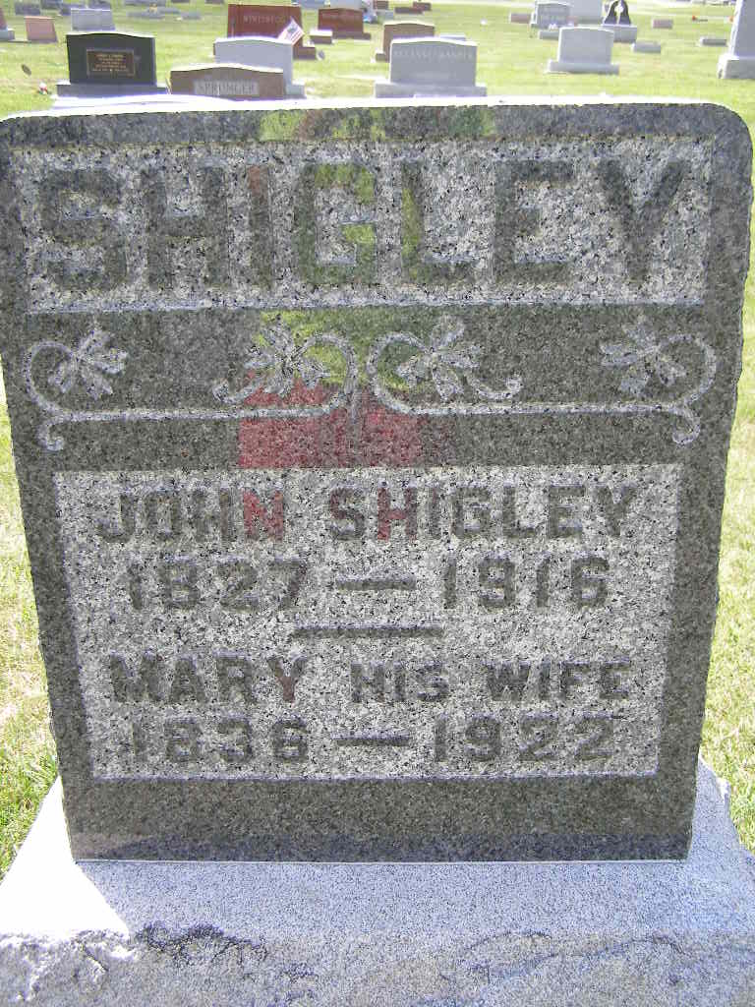
Photo by Shaunda Bedwell Opdycke
Indiana, U.S., Death Certificates, 1899-2017
Name John Shigley
Gender Male
Race White
Marital Status Married
Age 88y 6m 8d
Birth Date 1 Oct 1827
Birth Place Ohio
Death Date 28 Apr 1916
Death Place Berne, Adams, Indiana, USA
Death Registration Date 1916
Father George Shigley
Mother Barbara Fogle
Spouse Mary Shigley
Informant George D Shigley
Burial 5-1-1916 MRE
**
Biery-Yager Funeral Home Record, Adams County, Indiana
John Shigley: Died April 28, 1916 at Berne from carcinoma; Age 88 years, 6 months, 8 days; Married; Dunkard; Retired Farmer; Funeral May 1, 1916 at home; Buried at MRE Cemetery; Charge to Mrs. Shigley

