William Sheets
May 3, 1859 – January 14, 1906

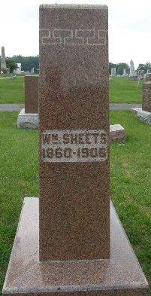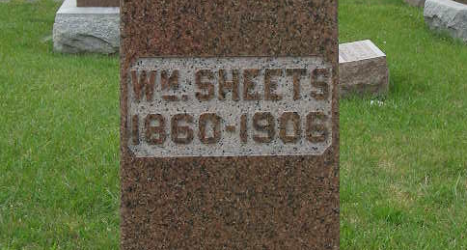
Photos by Shaunda Bedwell Opdycke
DEATH OF WM. SHEETS
William Sheets, of Berne, one of the best known citizens of this county, died suddenly at Fort Wayne at 10 o'clock Sunday night.
While there seems to be nothing mysterious about his death, the cause is given was heart trouble. The Fort Wayne Journal Gazette gave the following account of his death: Attacked by an affection of the heart, William Sheets, a traveling man, whose home is at Berne, Indiana, died suddenly in a room adjoining his offices, in the Pixey-Long block, in this city, about ten o'clock Sunday night. A woman who acted as his book keeper discovered him in a dying condition and spread the alarm and Deputy Coroner Duemling, who hastened to be in the vicinity, arrived at the unfortunate man's bedside just in time to see him breathe his last. Dr. Dumling [sic] stated that there was no ground for suspecting foul play and that the death was due to a blood clot on the heart. Mrs. Sheets, the wife of the decedent, who was visiting relatives in the city, was notified of the death shortly after it occurred, and hurried to the scene. She was almost overcome by the shock and was unable to talk of it, save to grieve at the loss of her husband. The couple had no children. The decedent was about fifty years of age and for many years was a druggist at Berne and one of the most influential residents at that place. Of late years he had been traveling for the Mills Novelty company, making his headquarters in this city. He maintained an office in the Pixey-Long block and had a sleeping apartment adjoining. It was in this room that his death occurred. Shortly after ten o'clock Sunday night a woman who acted as his clerk made the discovery that he was very ill and she called to the elevator boy, who notified Mr. Dan Clemens, proprietor of the Germanis cafe. Mr. Clemens hurried up to the room of Sheets and found him gasping for breath. Dr. Dueming [sic] happened to be in the cafe and Mr. Clemens called him. The physician arrived in the room just before Sheets died. Mr. Sheets was well and favorably known about Fort Wayne, holding membership in the Eagles lodge and the Travelers' Protective association in this city. He was a man of pleasing personality and was held in high regard by his friends here and also at his home in Berne. The remains were removed by Undertaker Peltier to the home of J. E. Crane, of 227 Baker street, a brother-in-law of Mr. Sheets, and at whose home Mrs. Sheets had been visiting. It is possible that a post mortem examination of the remains will be held and until the coroner has completed his investigation of the case, no funeral arrangements will be made.

Decatur Democrat, Adams County, Indiana
Thursday, Jan. 18, 1906
**
Acting upon the advice of Chief of Police Ankenbruck, Captain Reichelderfer and Sergeant Pappert, who made an investigation of circumstances surrounding the death of William Sheets, Coroner Stults last evening decides to detain Miss Rose Langenhoss, who acted as a bookkeeper for Sheets, and who was the first to discover that Sheets was dying. The young woman was removed to the county jail by Sheriff Grice last evening. To carefully investigate all suspicion of foul play, Deputy Coroner Duemling yesterday removed the stomach and kidneys of the dead man and sent them to Dr. W. O. Gross, for the purpose of having their contents examined. While there is little to lead to a suspicion that Sheets' death was due to other cause than an affection of the heart, the circumstances surrounding the death are somewhat peculiar and the coroner felt that the steps he took were necessary. By ??? examination yesterday by Dr. Duemling showed that death was not due to a heart clot as was first thought. The death of Sheets occurred in his rooms in the Pixley-Long block, Sunday night. It is said he had apparently been in the best of health on Sunday and the first intimation of his fatal illness was when Miss Langenhoss called the elevator boy in the building that Sheets was dying. As a matter of fact, there is nothing as yet to cause suspicion of any sorts directed toward Miss Langenhoss. The real cause for her detention was that she does not reside here and is little known here and the officers believed she should be detained until the cause of Sheets' death is determined. As Dr. Gross is compelled to leave the city today, he will likely not take up the analysis of the contents of the internal organs before Wednesday. Miss Langenhoss is a young woman of pleasing appearance, who made a favorable impression upon the coroner and police officer. She is twenty-two years of age and says her home is in Canada. She procured a position some time ago with Sheets as a bookkeeper and had intended this summer to engage in a business venture with him. Her brother is a balloonist and she herself has made a number of parachute leaps. She had intended purchasing, with Sheets, a balloon and she was to make ascensions and leaps in a circuit of county fairs.
Fort Wayne Journal Gazette, Allen County, Indiana
**
Dr. W. O. Gross, who made chemical tests of the stomach of William Sheets, who died suddenly in his rooms in the Pixley-Long block last Sunday, made his report to Coroner Stults Thursday. No poison was found and it was determined that death was caused by alcoholic congestion. As a result of these findings, Coroner Stults ordered the release of Rose Langenhoss, who has been held in the county jail as a witness. - Fort Wayne Journal Gazette
Decatur Democrat, Adams County, Indiana
Thursday, Jan. 25, 1906
**

Indiana, U.S., Death Certificates, 1899-2017

Name William Sheets
Gender Male
Race White
Marital Status Married
Age 46y 8m 11d
Birth Date 3 May 1859
Birth Place Texas
Death Date 14 Jan 1906
Death Place Fort Wayne, Allen, Indiana, USA
Death Registration Date 1906
Father Philip Sheets b. Germany
Mother Mary Monger b. Germany
Spouse Clara D Sheets, informant
Burial Berne, Ind. 1/16/1906

