Mabel Sylvia (Harms) Sharp
June 9, 1896 – December 18, 1973

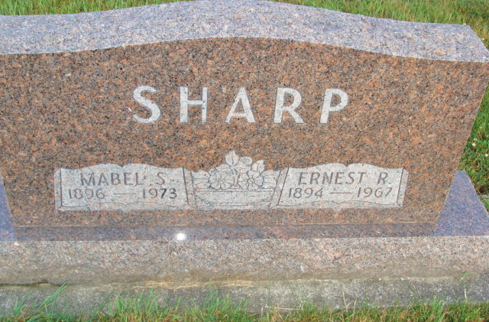
Photo by Alicia Kneuss

Former county resident dies

Mrs. Mabel Sharp, 76, a former resident of Hartford township and widow of Ernest Sharp, died at 11:10 a.m. Tuesday at the home of a daughter, Mrs. James (Evelyn) Patton of Goshen.
Born in Chatsworth, Ill. on June 9, 1896, she was the daughter of Mr. and Mrs. Fred Harms, and was married on December 22, 1915, to Ernest Sharp, who preceded her in death in February of 1967.
Surviving are three daughters, Mrs. Patton of Goshen; Mrs. Ralph (Mildred) Enoch of Syracuse; and Mrs. Earl (Lela) Moser of route 1, Geneva; two sisters, Mrs. Earl Hoelscher of Chatsworth, Ill.; and Mrs. Margaret Hindhorse of Pontiac, Ill.; one brother, George Harms of Pontiac, Ill.; nine grandchildren and 21 great-grandchildren.
Funeral services will be held at 1:30 p.m. Friday at the Yager funeral home, with Rev. Donald Young officiating. Burial will be in the M.R.E. cemetery. Friends may call at the funeral home after 7 p.m. tonight.

Decatur Daily Democrat, Adams County, Indiana
Wednesday, Dec. 19, 1973
**

WIDOW OF ERNEST SHARP DIES AT DAUGHTER’S HOME

Mrs. Mable S. Sharp, 74, widow of Ernest Sharp and long a resident of ... Township, dies at 11:10 a.m. today at the home of a daughter, Mrs. … Gerber, where she had lived recently. The Patton family’s …Georgia Road, Goshen. Mrs. Sharp had been bedfast 10 days … over a longer period.
Mrs. Sharp was a native of ..., Illinois where she was born …, a daughter of Mr. and Mrs. … who resided in … township since 1942 and until his death in February of 1967. Attended the Cross United church in Berne while residing in this …
Surviving are three daughters, Mrs. … (Evelyn) Patton, Goshen; Mrs. … (Mildred) Enock, Syracuse and Mrs. Carl (Lela) Moser, R.R. 1, Berne, ... grandchildren and 22 great-grandchildren; a brother, George …, Pontiac, Illinois and two sisters, Mrs. … Hoebcher, Chatsworth, Illinois, Mrs. Margaret Hind..., …, Illinois.
…. Sharp is deceased.
The body is at the Yager Funeral home where friends may call after 7 p.m. today and where services will be held at … p.m. Friday. Rev. Donald Young pastor of the West Missionary church will … and burial will be in the M.R.E. cemetery.

Burial on Lot N ½ 25 Sec 3, 4th Add.
Death Date: Dec 1973; Burial Date: 21 Dec 1973

Berne (IN) Library Heritage Room
MRE Obits 1973-1984, image 033

