Lee Bishop Sharp
September 22, 1894 – November 9, 1976

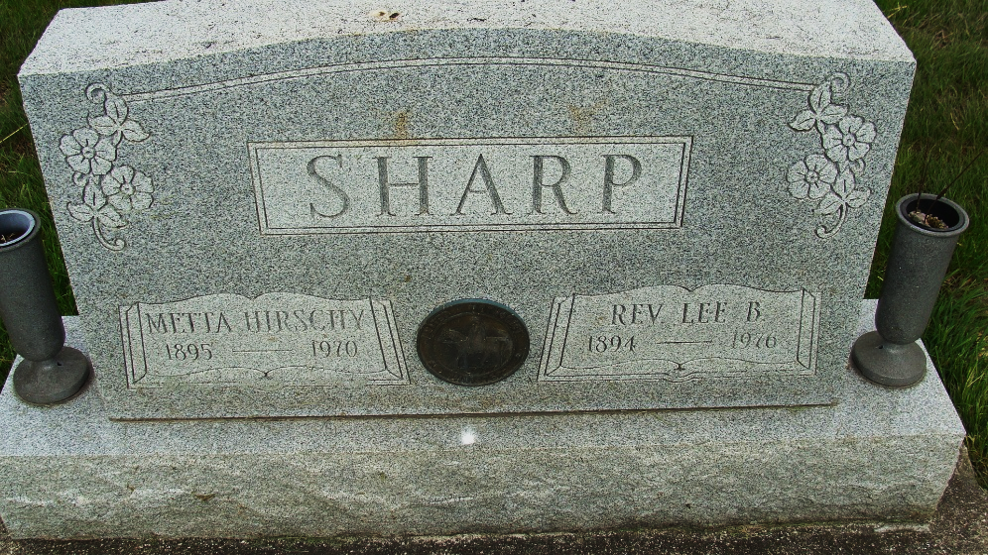
Photo by Alicia Kneuss

Indiana, U.S., Death Certificates, 1899-2017

Name Lee Bishop Sharp
Gender Male
Race White
Marital Status Widowed
Age 82
Birth Date 22 Sep 1894
Birth Place Tennessee
Death Date 9 Nov 1976
Death Place Wabash, Wabash, Indiana, USA
Death Registration Date 1976
Father Harvey Sharp
Mother Rebecca A. Graves
Informant Florence Emrick
Burial too faded to read

