John Preston Shannon
July 13, 1956 – December 25, 1984

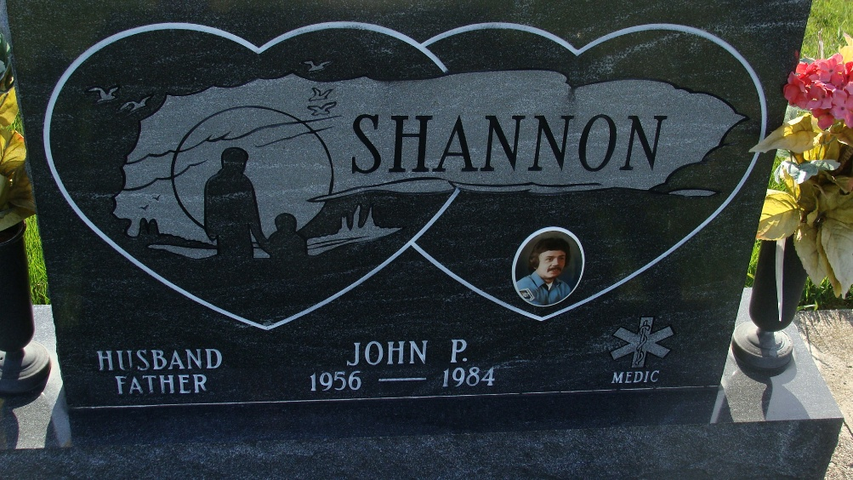
Photo by Alicia Kneuss

Indiana, U.S., Death Certificates, 1899-2017

Name John P. Shannon
Gender Male
Race White
Marital Status Married
Age 28
Birth Date 13 Jul 1956
Birth Place Indiana
Death Date 25 Dec 1984
Death Place Valparaiso, Porter, Indiana, USA
Death Registration Date 1984
Father Charles M. Shannon
Mother Edna M. Carlyle
Spouse Monica Liechty Shannon, informant
Burial M R E Cemetery 12/28/1984

