Candice Renae Shannon
July 26, 1983 – July 22, 2001

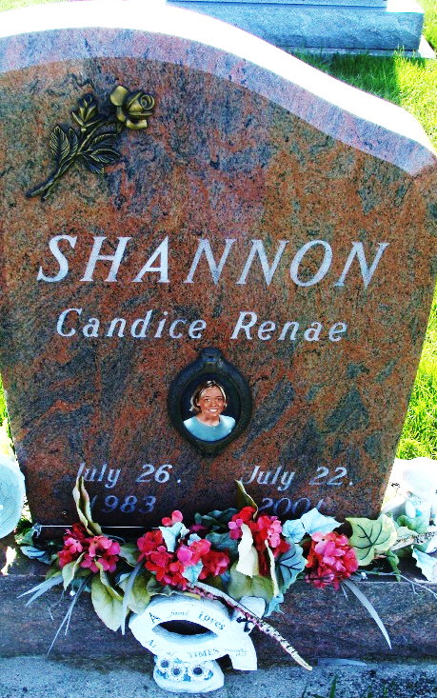
Photo by Alicia Kneuss

Candice R. Shannon, 17, of Decatur, who belonged to Zion Lutheran Church, Friedheim, and its youth group, died Sunday, July 22, 2001, in Adams County. The Porter County native was enrolled at IPFW and had been accepted into the Army National Guard.
Surviving are her mother and stepfather, Kent and Monica Stoppenhagen; brothers, Tyler, Drew and Clayton Stoppenhagen, all of Decatur; a sister, Madison Stoppenhagen of Decatur; grandparents, Edna Shannon of Hemet, Calif., and Amos and Beverly Liechty of Berne; stepgrandmother, Merilyn Stoppenhagen of Decatur; and great-grandmother, Margaret Fenstermaker of Berne. Her father, John Shannon, preceded her in death.
Services are 10 a.m. Wednesday at Zion Lutheran Church. Calling is from 1 to 5 and 6 to 9 p.m. Tuesday at Zwick & Jahn Funeral Home, Decatur. Burial will be in MRE Cemetery, Berne.
Memorials are to a scholarship fund at Wyneken Memorial Lutheran School in her memory. Information provided by Zwick & Jahn Funeral Home, Decatur, 1-219-724-9164.

News-Sentinel, The (Allen County, Indiana)
Monday, July 23, 2001

