Stanley Paul Shank
June 18, 1946 – July 20, 1985

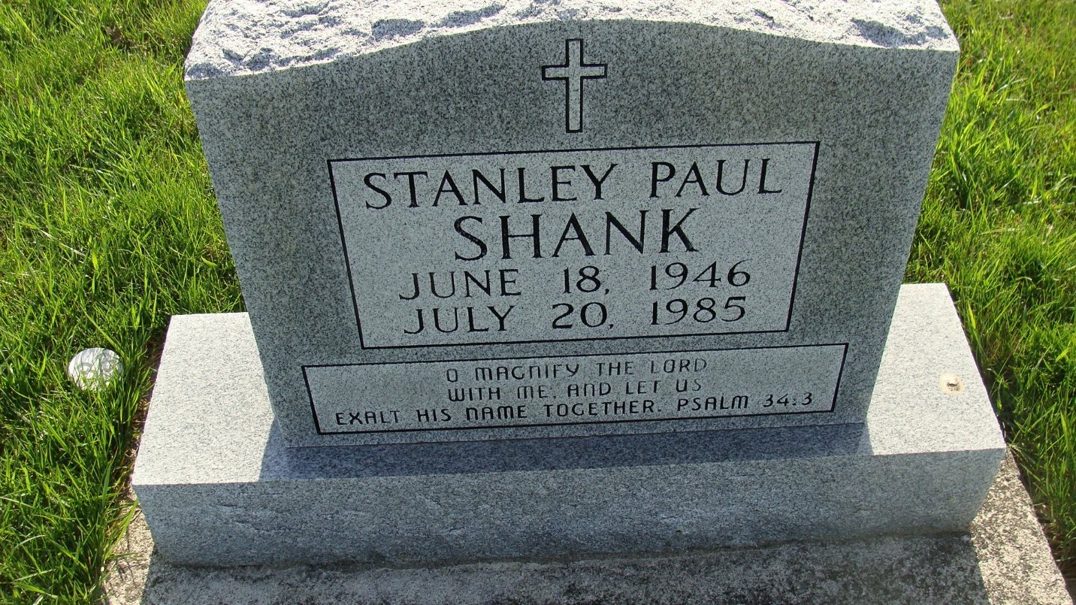
Photo by Alicia Kneuss

Michigan, U.S., Death Index, 1971-1996
Name Stanley P Shank
Birth Date 18 Jun 1946
Death Date 20 Jul 1985
Gender Male
Residence East Grand Rapids, Kent, Michigan
Place of Death Grand Rapids, Kent, Michigan
**
Stanley Paul Shank from tree Wonderly Osterc Family Tree
Birth 18 Jun 1946
Residence 1964 Fort Wayne, Allen, Indiana, USA
Death 20 Jul 1985 Grand Rapids, Kent, Michigan, USA
Father Floyd Aaron Shank (1911-2000)
Mother Adah Verena Baumgartner (1918-1971)
46109 People 6 Records 6 Sources

