Earl K. Shalley
April 10, 1883 – April 6, 1928

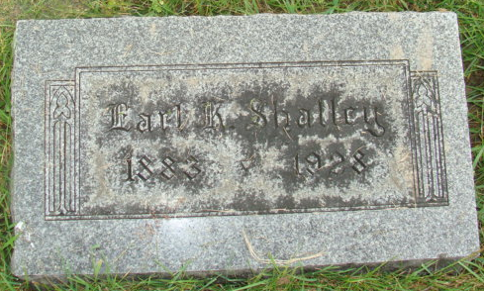
Photo by Alicia Kneuss

Indiana, U.S., Death Certificates, 1899-2017

Name Earl K. Shalley
Gender Male
Race White
Marital Status Married
Age 44y 11m 25d
Birth Date 10 Apr 1883
Birth Place Indiana
Death Date 6 Apr 1928
Death Place Fort Wayne, Allen, Indiana, USA
Death Registration Date 1928
Father Daniel Shalley
Mother --- Kretner
Spouse Wilda Shalley
Informant Mrs. Earl K. Shalley
Burial M.R.E. Cemetery 4/9/1928
**

Indiana, U.S., Marriage Index, 1800-1941

Name Earl K Shalley
Marriage Date 25 Jun 1908
Marriage Place Adams, Indiana, USA
Spouse Name Wilda Gottschalk

