Daniel L. Shalley
November 23, 1857 – August 10, 1944

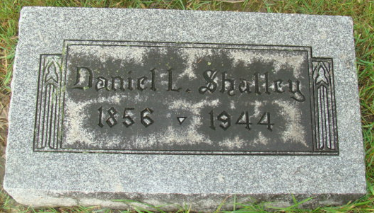
Photo by Alicia Kneuss

Rites Held Sunday for D. L. Shalley

Funeral services were held Sunday afternoon in the Stanley Basinger funeral home for D. L. Shalley, 88, retired Bluffton merchant, who died last Thursday in the Bluffton Community hospital.
Shalley had been in the hospital for the last six days, after falling and fracturing his shoulder. Death was due to this injury and to the infirmities of age.
The last member of a family of 12, he came to Bluffton from Berne, Ind., 22 years ago, and for many years operated a variety store here. A son, Harry K. Shalley, with whom he was associated in business died last year, and his wife died in 1941. Mrs. Opal Egly, of Miami, Fla., is the only surviving child.
Rev. V. C. Oppermann, pastor of St. John’s Reformed church, officiated at the rites here Sunday, and later in the day in the Reformed church at Berne, Ind., where Shalley was buried.

Unknown newspaper clipping
**

Geneanet Community Trees Index

Name Daniel Shally
Gender M (Male)
Birth Date 23 nov. 1857 (23 Nov 1857)
Birth Place Lebanon Co. PA (Lebanon), Pennsylvania, USA
Father Henrich Shally
Mother Elizabeth Lerch
**

Ohio, U.S., Death Records, 1908-1932, 1938-2022

Name Daniel Shalley
Death Date 10 Aug 1944
Death Place Allen, Ohio, USA
**

Daniel L Shalley from tree Shalley Family Tree

Birth 23 Nov 1857 Lebanon, Pennsylvania, USA
Marriage 26 Jan 1882 Wells, Indiana, USA
Residence 1940 Bluffton, Allen, Ohio, USA
Death 10 Aug 1944 Berne, Adams, Indiana, USA
Father Henry B Shally (Born 1809)
Mother Elizabeth Lerch (1817-1881)
Spouse Catherine Kretner (1862-1941)
133 People 14 Records 16 Sources

