Caroline L. (Kratner) Shalley
June 1862 – February 15, 1941

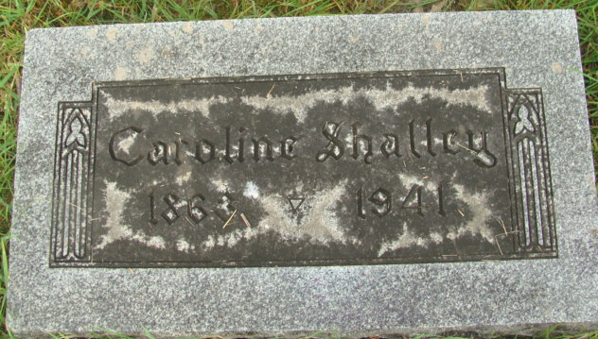
Photo by Alicia Kneuss

Mrs. Dan Shalley Is Taken By Death
Mrs. Dan Shalley, 78, for many years a resident of Berne, died Sunday at her home in Bluffton, Ohio, where she and her husband had operated a store for a number of years.
Surviving are the husband, one son and one daughter. Funeral services will be held at the Berne Reformed church Tuesday afternoon at 2 o’clock, with burial in the M. R. E. cemetery.
Adams County, Indiana Historical Museum
1941a Jan-Jun Scrapbook, Image 22
Handwritten-Mon. Feb. 17, 1941
**

Name: Carrie L Shalley
Event Type: Death
Event Date: 15 Feb 1941
Event Place: Allen, Ohio, United States
Event Place (Original): , Allen, Ohio, United States
Residence Place: Ohio
Page: 1612
Citing this Record
"Ohio Death Index, 1908-1932, 1938-1944, and 1958-2007", database, FamilySearch (https://familysearch.org/ark:/61903/1:1:VKY7-S3V : 12 November 2019), Carrie L Shalley, 1941.

