Harry Shaefer
November 22, 1891 – April 4, 1894

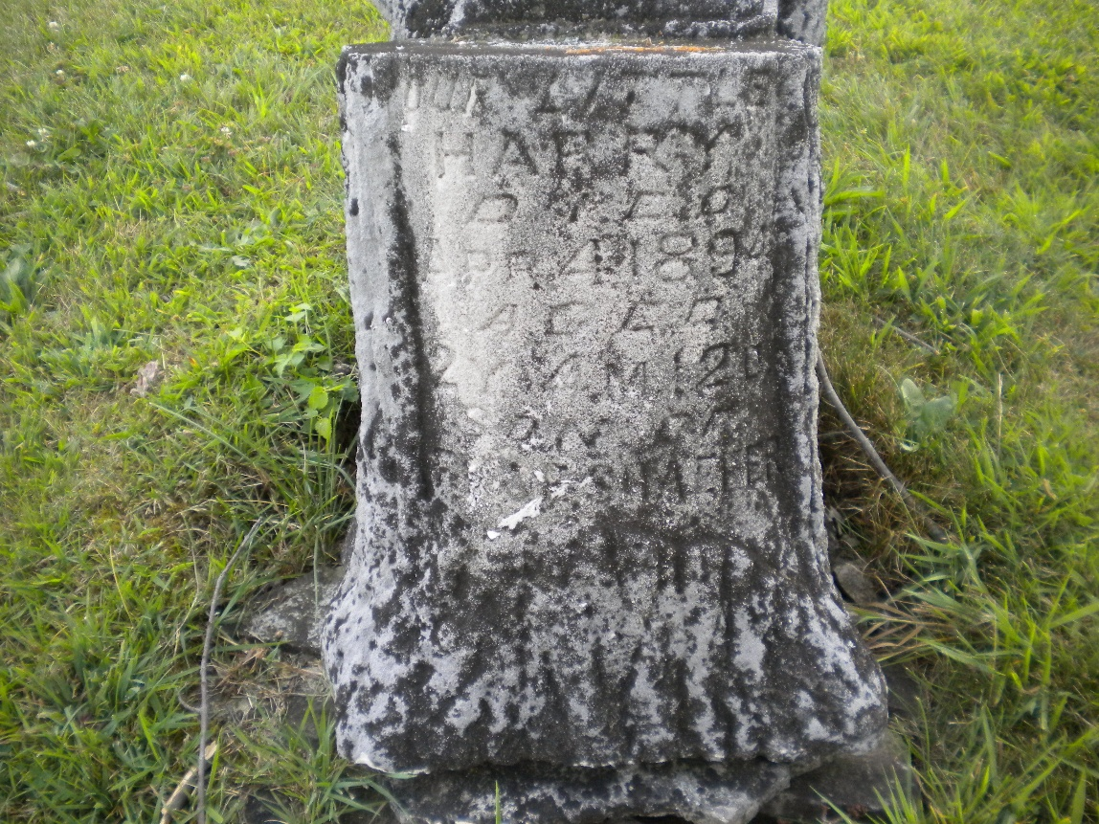
Photo by DSON1492

No further information found at this time.

