F. K. Shaefer
1868 – 19--

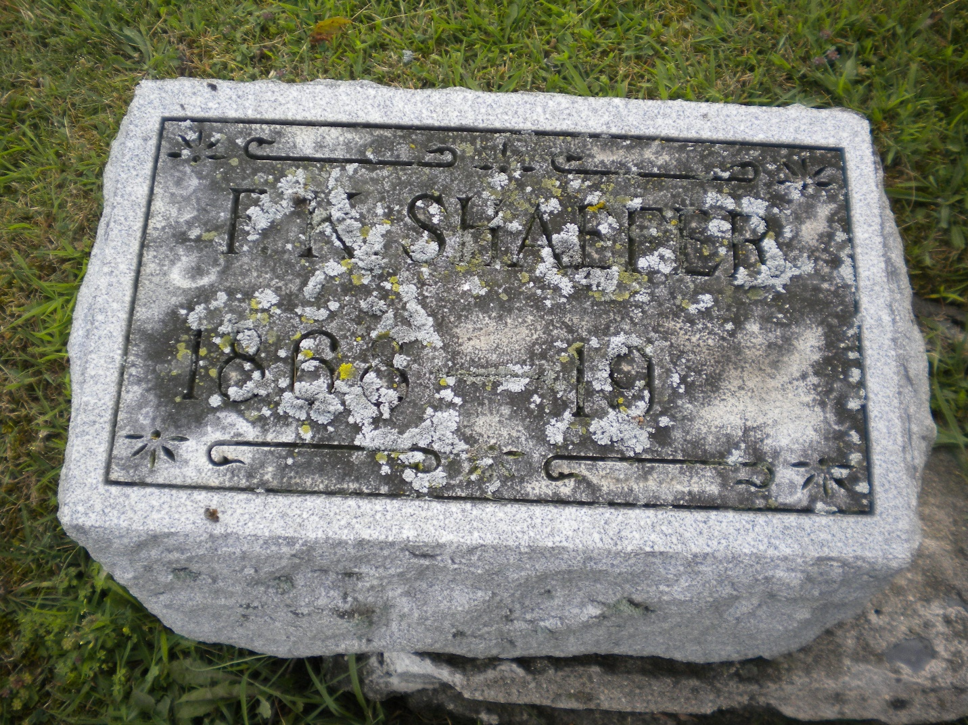
Photo by DSON1492

No further information found at this time.

